THE HASHEMITE UNIVERSITY
Faculty of Engineering — Computer Engineering Department



AI-Powered Phishing Email Detection System
Using ModernBERT Multi-Expert Architecture

PROJECT TEAM
Student ID | Student Name
2136791 | Ahmad Mahmoud Al-zawahrah
2145308 | Mohammad Bassam Al-shamaseen
2135141 | Mahmoud Riyad Fahhar
2136806 | Mohammad Haithem Abdel Razzaq
2136927 | Mohammad Omar El-Omari

Project Supervisor
Dr. Mohammad Al-hammouri
Department of Computer Engineering

Academic Year 2026

ACKNOWLEDGMENT
We would like to express our sincere gratitude to Dr. Mohammad Al-hammouri, our project supervisor, for his continuous guidance, invaluable feedback, and unwavering support throughout this project. His expertise in machine learning and cybersecurity was instrumental in shaping both the direction and quality of our work.

We extend our appreciation to the Department of Computer Engineering at The Hashemite University for providing the academic environment and computational resources that made this research possible. We also thank the faculty members who offered constructive feedback during our project presentations.

We acknowledge the open-source community — particularly the developers of ModernBERT, HuggingFace Transformers, FastAPI, and XGBoost — whose tools formed the technical foundation of this system. Finally, we thank our families and colleagues for their patience and encouragement during the intensive development phases of this project.

ABSTRACT
Phishing attacks remain among the most prevalent and destructive forms of cybercrime, targeting individuals and organizations through deceptive email communications. Traditional rule-based detection systems and conventional machine learning approaches have proven insufficient against sophisticated, continuously evolving phishing campaigns. This project presents an AI-powered phishing email detection system leveraging a novel multi-expert architecture built upon ModernBERT, a state-of-the-art transformer model optimized for long-document understanding.

The proposed system employs three specialized ModernBERT expert models trained on carefully curated datasets: a Binary Phishing Risk Expert achieving 99.39% F1-score and 99.98% ROC-AUC, a Cyber Context Expert for 12-label multilabel classification at 97.87% macro F1-score, and an Intent Context Expert for 22-class intent classification at 96.65% F1-score. These expert outputs are fused through an XGBoost Fusion Layer achieving 95.7% accuracy on a curated 46-email calibration and validation set of real-world labeled emails. Auxiliary rule-based and threat-intelligence checks covering header authentication, domain-risk indicators, blacklist checking, and trusted-domain safeguards provide additional structured signals to the fusion pipeline.

The full-stack deployment includes a FastAPI backend, a dark-themed interactive web application, a Chrome browser extension for real-time Gmail analysis, a Telegram bot interface, Gmail and Outlook API deep scan integration with SPF/DKIM/DMARC header extraction, and an external threat-intelligence scanner leveraging Google Safe Browsing, URLScan.io, and VirusTotal. The system operates entirely on local infrastructure, preserving complete user privacy. Experimental results demonstrate a 100% phishing detection rate, 0% false positive rate, and sub-two-second pipeline response time on consumer-grade GPU hardware.

TABLE OF CONTENTS
Chapter 1: Introduction | 6
Chapter 2: Background Theory | 9
Chapter 3: Dataset Preparation and Methodology | 13
Chapter 4: System design and Architecture | 21
Chapter 5: Implementation and Results | 31
Chapter 6: Economic, Ethical, and Contemporary Issues | 42
Chapter 7: Conclusion and Future Work | 44
References | 46
Appendices | 47

LIST OF FIGURES
Figure 1.1 — Global Phishing Attack Growth 2019–2026 | 6
Figure 1.2 — Hidden URL Attack: Anchor Text vs. Actual Destination | 7
Figure 2.1 — BERT Transformer Encoder Architecture | 9
Figure 2.2 — BERT vs. ModernBERT Context Window Comparison | 10
Figure 2.3 — XGBoost Gradient Boosting: Sequential Tree Construction | 11
Figure 3.1 — Raw Email Text vs. Cleaned Text | 16
Figure 3.2 — Duplicate and Conflict Analysis Results | 17
Figure 3.3 — Jupyter Notebook Cleaning Workflow Screenshot | 18
Figure 3.4 — Final Binary Dataset Class Distribution | 19
Figure 4.1 — System Architecture: Four-Tier Pipeline | 21
Figure 4.2 — Expert Model Training Workflow | 22
Figure 4.3 — Intent Context Expert: 22-Class Taxonomy | 24
Figure 4.4 — Fusion Layer: Inputs and Final Verdict | 26
Figure 4.5 — Gmail/Outlook Deep Scan OAuth Flow | 27
Figure 4.6 — Chrome Extension Architecture | 28
Figure 5.1 — Web Application Main Interface | 32
Figure 5.2 — Analysis Result Panel: Phishing Email | 33
Figure 5.3 — Email Details with Hidden URL Detection | 34
Figure 5.4 — Gmail Deep Scan: SPF/DKIM/DMARC Badges | 35
Figure 5.5 — External Threat-Intelligence Scanner | 36
Figure 5.6 — Chrome Extension Popup Interface | 37
Figure 5.7 — Chrome Extension Gmail Overlay Warning | 37
Figure 5.8 — Telegram Bot Interaction | 38
Figure 5.9 — Windows Sandbox Launched | 39
Figure 5.10 — Training Loss and Validation F1 Curves | 39
Figure 5.11 — Confusion Matrix: 46-Email Calibration/Validation Set | 41
Figure 5.12 — ROC Curve: Binary Expert | 41

LIST OF TABLES
Table 2.1 — Comparison of Existing Phishing Detection Solutions | 12
Table 3.1 — Training Dataset Sources Summary (13 Sources) | 13
Table 3.2 — Final ModernBERT Training Dataset Composition | 18
Table 4.1 — Cyber Context Expert: 12 Labels and Weights | 23
Table 4.2 — Intent Context Expert: Risk and Legitimacy Weights | 24
Table 4.3 — Project Timeline and Team Roles | 30
Table 4.4 — Project Budget Estimation | 30
Table 5.1 — Development Environment Specifications | 31
Table 5.2 — Expert Model and Fusion Layer Performance Metrics | 40
Table 5.3 — Complete System-Level Performance Metrics | 40

CHAPTER 1: INTRODUCTION

1.1 Project Overview
This project, titled 'AI-Powered Phishing Email Detection System Using ModernBERT Multi-Expert Architecture,' addresses the critical cybersecurity challenge of identifying phishing emails with high accuracy and full explainability. Phishing is a social engineering attack that deceives recipients into divulging sensitive credentials, financial information, or granting unauthorized system access by impersonating a trusted entity. According to the Anti-Phishing Working Group (APWG), phishing attacks increased by over 150% between 2019 and 2023, with annual global losses exceeding USD 3.5 billion.

The system integrates modern deep learning, classical machine learning, rule-based heuristics, and real-time threat intelligence into a cohesive, locally deployable platform. It is accessible through multiple interfaces: a dark-themed web application, a Chrome browser extension for real-time Gmail analysis, Gmail and Microsoft Outlook API integration, a Telegram bot, and a Windows Sandbox launcher for safe URL inspection.
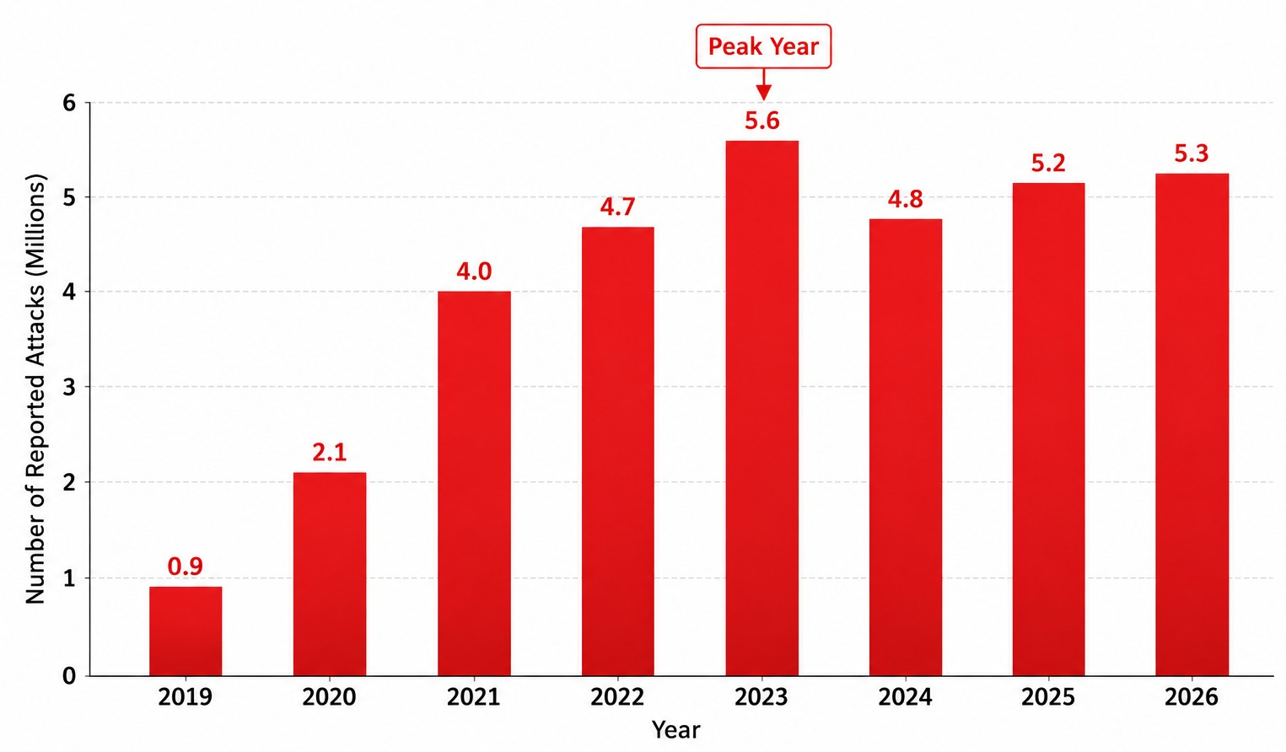
Figure 1.1 — Global Phishing Attack Growth 2019–2026 (Source: APWG) [5]

1.2 Problem Statement
Existing phishing detection mechanisms suffer from three fundamental limitations that this project directly addresses. First, rule-based systems are brittle and require constant manual maintenance as attackers continuously adapt their techniques. Second, single-model classifiers fail to distinguish semantically similar phishing and legitimate security emails — a genuine Steam Guard verification email and a phishing email impersonating Steam may use identical urgency language, creating a false positive problem that erodes user trust. Third, commercial email security gateways operate as opaque black boxes providing no transparency or explanation to users.

A fourth and particularly underaddressed problem is the hidden URL attack: an attacker embeds a malicious hyperlink behind innocent anchor text, so the user sees 'Click here to verify your PayPal account' while the actual destination is 'https://paypa1-secure.xyz/steal'. Conventional detectors that analyze only the visible text entirely miss this class of attack.
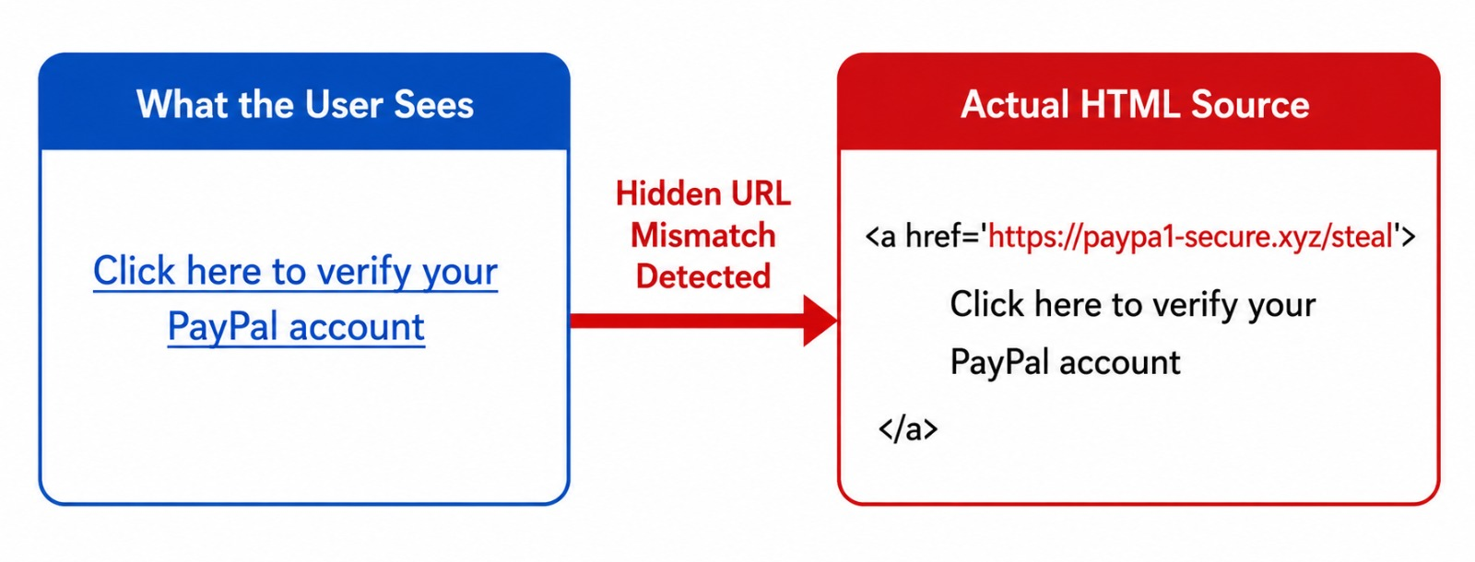
Figure 1.2 — Hidden URL Attack: Displayed Anchor Text vs. Actual Malicious Destination

1.3 Project Objectives
The measurable technical and non-technical objectives of this project are:
- Achieve a Binary Expert phishing classification F1-score exceeding 99% on the benchmark dataset.
- Develop a multilabel Cyber Context classifier capturing 12 linguistic attack-tactic signals.
- Build an Intent Context classifier categorizing email intent across 22 classes spanning attack and legitimate categories.
- Fuse expert outputs into a final verdict using a trained XGBoost Fusion Layer achieving above 95% accuracy on real-world calibration/validation emails.
- Systematically detect and flag hidden anchor-URL mismatches in all analyzed emails.
- Integrate Gmail API and Microsoft Outlook API for full SPF/DKIM/DMARC header verification.
- Deploy a Chrome Extension for real-time Gmail analysis without requiring page reload.
- Deliver a fully local, privacy-preserving system with no email content transmitted to external servers.

1.4 Scope and Limitations
Scope covers: full email content analysis (subject, body, headers, embedded URLs), multi-modal AI classification using transformer-based and gradient-boosted models, real-time browser integration, Gmail and Outlook API connectivity, and external threat-intelligence checking. Current limitations include: English-language emails only in the current version; local GPU required for production-speed inference (NVIDIA RTX 5060 8GB was used); Gmail OAuth requires Google Cloud application verification for deployment beyond the development test environment.

1.5 ABET Student Outcomes Alignment
This project demonstrates: (a) applying engineering knowledge through transformer networks and probability theory; (b) designing a multi-component system meeting complex real-world requirements; (d) functioning on a multidisciplinary 5-person team spanning ML engineering, backend development, frontend development, and systems integration; (e) identifying and solving the hidden URL, false positive, and OAuth PKCE engineering problems; (f) ethical responsibility through privacy-by-design architecture and read-only API scopes; (g) effective communication through this report and live demonstration; (k) use of modern engineering tools including PyTorch, HuggingFace Transformers, FastAPI, and Chrome Extension APIs.

CHAPTER 2: BACKGROUND THEORY

2.1 Transformer Architecture and BERT
The transformer architecture (Vaswani et al., 2017) uses multi-head self-attention to model long-range dependencies in text without recurrence, enabling parallel computation and superior scalability over earlier RNN-based approaches. Each attention head learns to focus on different aspects of the input, allowing the model to simultaneously capture syntactic structure, semantic meaning, and domain-specific patterns.

BERT (Devlin et al., 2019) extends the transformer encoder with bidirectional pre-training on two tasks: Masked Language Modeling (MLM) and Next Sentence Prediction (NSP). This produces rich contextual token embeddings where the same word receives different representations depending on its surrounding context — critical for understanding phishing language where innocuous words like 'urgent' or 'verify' carry threat-relevant meaning only in specific contexts.

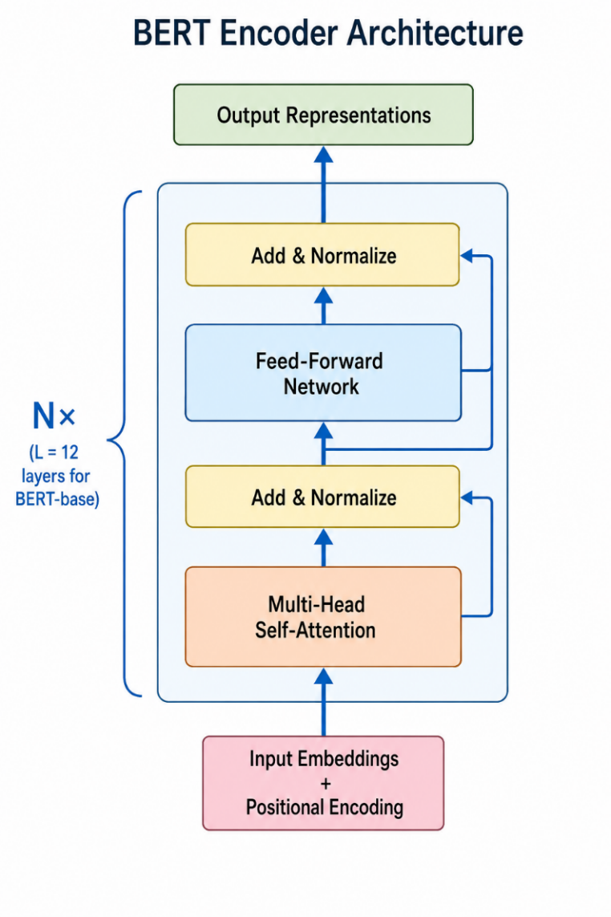
Figure 2.1 — BERT Transformer Encoder Architecture (Vaswani et al., 2017) [1]

2.2 ModernBERT
ModernBERT (Warner et al., 2024) introduces several improvements over the original BERT architecture, making it more suitable for processing long and complex text such as email data. One of its main enhancements is the extended context window of up to 8,192 tokens, enabled by Rotary Positional Embeddings (RoPE). This allows the model to process entire emails, including headers, HTML content, and embedded links, without truncation — a key limitation in the original BERT model, which is restricted to 512 tokens. In addition, ModernBERT uses Flash Attention 2, which significantly improves memory efficiency when handling long sequences, making it more practical to run on limited or consumer-level hardware. It is also pretrained on approximately 2 trillion tokens from a wide range of sources, including code repositories and technical documents, which improves its understanding of domain-specific and cybersecurity-related language.
Although ModernBERT supports sequences up to 8,192 tokens, this study uses a maximum sequence length of 1,024 tokens during training. This choice was mainly driven by computational constraints, as longer sequence lengths significantly increase training time and require more advanced GPU resources or higher-tier Colab subscriptions. Moreover, after careful preprocessing and cleaning of the dataset, it was observed that most emails are not excessively long and do not require more than 1,024 tokens to capture their meaningful content. Therefore, 1,024 tokens was considered a practical and balanced setting that preserves important information while keeping training efficient and resource-friendly.

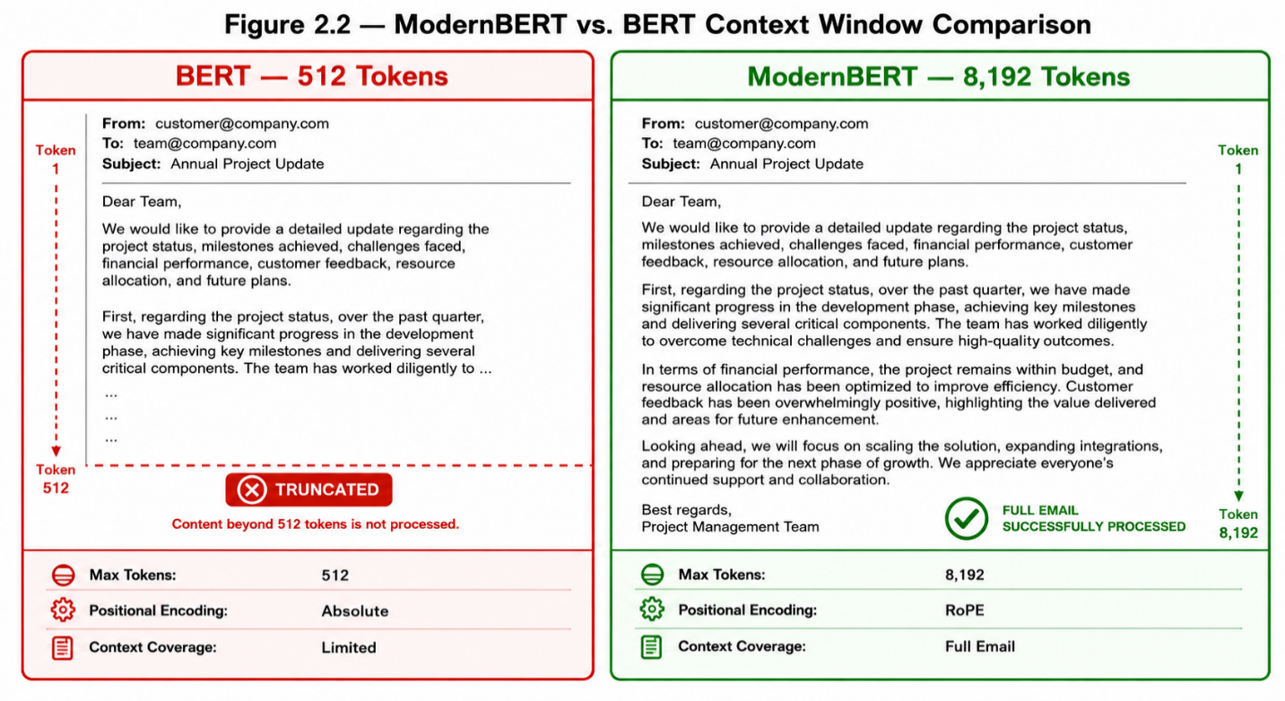
Figure 2.2 — Context Window Comparison: BERT (512 tokens) vs. ModernBERT (8,192 tokens) [4],[2]

2.3 XGBoost
XGBoost (Chen and Guestrin, 2016) is an ensemble learning algorithm based on gradient-boosted decision trees with built-in L1/L2 regularization. In this system, XGBoost serves as the Fusion Layer that combines the probabilistic outputs of all three expert models with structured signals from the auxiliary checks. XGBoost is well-suited to this heterogeneous input due to its robustness to feature scale differences, native support for missing values, and interpretability via feature importance ranking — which directly supports the system's explainability objective.
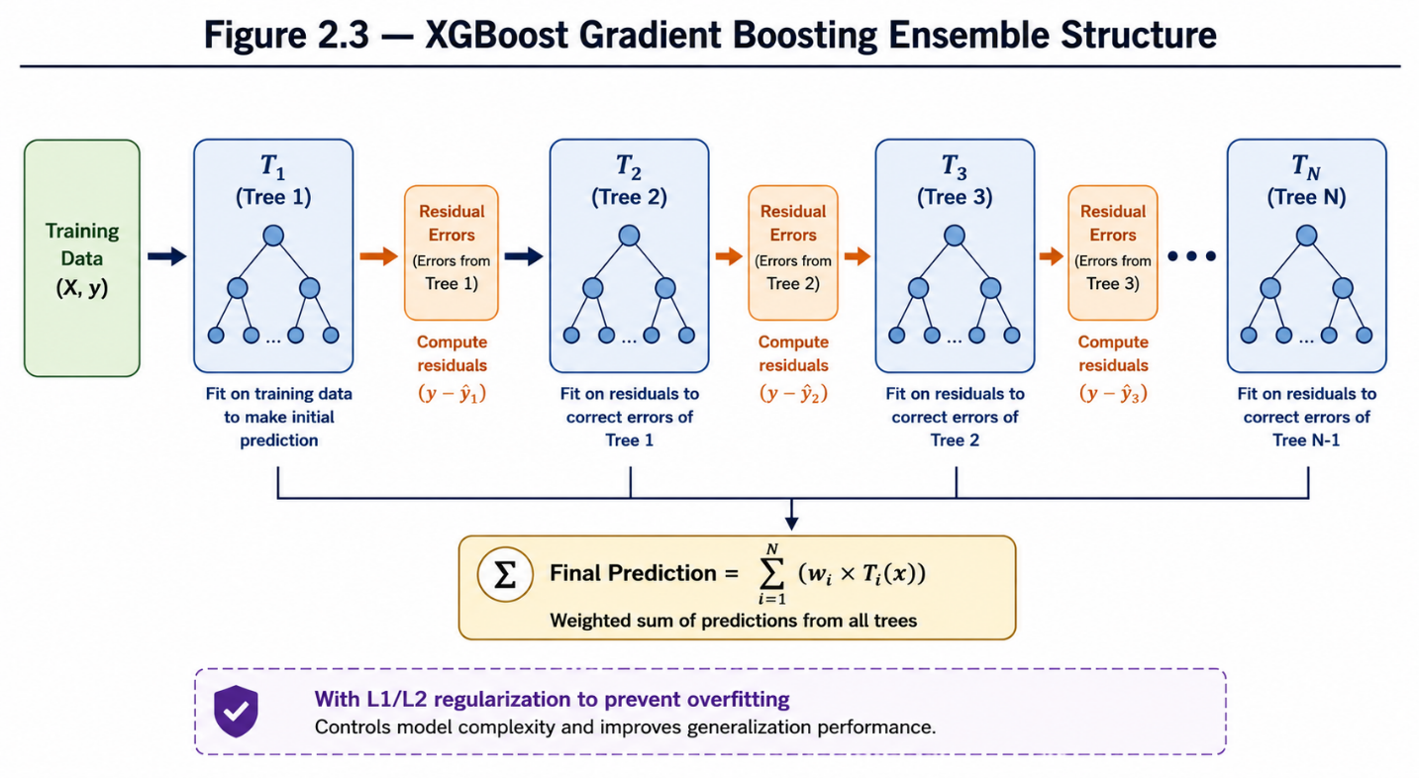
Figure 2.3 — XGBoost Gradient Boosting: Sequential Tree Construction [3]

2.4 Email Authentication Protocols
Three IETF-standardized protocols form the basis of email sender authentication. SPF (Sender Policy Framework, RFC 7208) allows domain owners to publish a list of authorized mail servers in DNS; receiving servers verify that incoming mail originates from an authorized IP address. DKIM (DomainKeys Identified Mail, RFC 6376) uses public-key cryptography to sign outgoing messages; recipients verify the signature using the sender's public key published in DNS. DMARC (Domain-based Message Authentication, Reporting and Conformance, RFC 7489) builds on SPF and DKIM by specifying a policy (none/quarantine/reject) for handling messages that fail authentication checks.

In this system, SPF/DKIM/DMARC results are extracted from the Authentication-Results and ARC-Authentication-Results headers of emails retrieved via the Gmail and Outlook APIs. When all three pass simultaneously, an additional trust multiplier (0.30x) is applied to the fusion score, implementing a principled authentication-based false positive reduction mechanism.

2.5 Review of Existing Solutions
Solution | Approach | Accuracy | Key Limitations | Year
SpamAssassin | Rule-based scoring | ~85% | Brittle, no ML adaptation | 2002+
PhishNet | URL blacklist | ~88% | URL-only, no body analysis | 2010
PhishBERT | BERT fine-tune | 97.2% | Single model, 512-token limit | 2022
LSTM Ensemble | Bi-LSTM + attention | 96.8% | No header authentication | 2023
MS Defender | Commercial cloud AI | ~98% | Closed-source, privacy concerns | Ongoing
This Project | ModernBERT Multi-Expert | 99.39% F1 | English only; GPU required | 2025
Table 2.1 — Comparison of Existing Phishing Detection Solutions

2.6 Design Standards and Constraints
- IEEE Std 730-2014 (Software Quality Assurance): All components subjected to systematic unit and integration testing.
- OWASP Email Security Guidelines: Input sanitization and output encoding applied throughout.
- RFC 7208 (SPF), RFC 6376 (DKIM), RFC 7489 (DMARC): Authentication extraction follows IETF standards.
- GDPR Article 5 (Data Minimisation): No email content retained after analysis session ends.
- ISO/IEC 27001: Least-privilege architecture; read-only API scopes exclusively.

CHAPTER 3: DATASET PREPARATION AND METHODOLOGY

3.1 Overview of Data Preparation Approach
The training pipeline relies on a heterogeneous collection of 13 publicly available phishing and legitimate email datasets. Two complementary preparation methodologies were employed in parallel: (1) Jupyter Notebook-based Python scripts for programmatic text cleaning, quality filtering, and deduplication; and (2) AI-assisted review for edge-case annotation, label verification, and label schema design. All outputs were manually spot-checked through random sampling before integration into the final training corpus. This methodology ensured both scale and quality in the final datasets.

3.2 Dataset Sources
Dataset | Type | Domain | Label Format
CEAS_08.csv | Real emails | Spam/phishing | Binary (0/1)
Ling.csv | Real emails | General email | Binary
TREC_05 / 06 / 07 | Real emails | Spam corpus | Binary
Nazario_5.csv | Real phishing | Phishing corpus | Binary
Nigerian_5 / Nigerian_Fraud | Real fraud | 419 scam emails | Binary
Phishing_Email.csv | Real emails | Mixed | Safe Email / Phishing Email
PhishFuzzer JSON (synthetic) | AI-generated | Augmented | Binary
meajor / Enron | Real legitimate | Corporate email | 0 = legitimate
infrastructure_phishing | JSON structured | Infrastructure | Binary
cross_domain_legitimate | CSV legitimate | Legitimate only | 0 = legitimate
Dataset_5971.csv | SMS/Email mixed | Ham/Spam/Smishing | Ham=0, Spam+Smishing=1
Phishing_validation | Validation set | Mixed | Safe Email / Phishing Email
Table 3.1 — Training Dataset Sources Summary (13 Sources)

3.3 The Three Training Datasets
3.3.1 Binary Dataset (binary_ULTIMATE.csv)
The Binary Dataset was assembled by collecting emails from all 13 sources listed above, with careful attention to maintaining a reasonably balanced representation of legitimate and phishing emails. After cleaning, normalization, quality filtering, conflict removal, and deduplication, the final dataset contains 89,855 rows stored as binary_ULTIMATE.csv. The final class distribution is moderately imbalanced but still suitable for binary training, with 41,981 legitimate emails (label=0, 46.7%) and 47,874 phishing emails (label=1, 53.3%). This distribution provides broad coverage of both classes while preserving the natural dominance of phishing samples collected from several threat-focused datasets.
3.3.2 Cyber Context Dataset (cyber_context_MASTER_FINAL.csv)
The Cyber Context Dataset uses the same base sources as the Binary Dataset, supplemented by an additional source (100k_dataset.csv) that provided further diversity in attack tactic coverage. The 12 multilabel classes were designed through a comprehensive research process: the team conducted an in-depth study of phishing attack taxonomy literature, identified all commonly exploited psychological and linguistic manipulation tactics, and refined the label set through extensive team discussion augmented by AI consultation. The selected labels are: urgency, fear, authority_pressure, trust_building, generic_greeting, call_to_action, confidentiality_pressure, credential_theft, bec, brand_impersonation, sender_spoofing, and email_security_language.

Annotation was performed using AI-assisted labeling: the methodology was first validated on a representative sample, verified to produce accurate and consistent classifications, then applied to the complete dataset with subsequent quality checks. The final dataset contains approximately 23 MB of cleaned, multilabel-annotated email data.
3.3.3 Intent Context Dataset (intent_context_MASTER_FINAL.csv)
The Intent Context Dataset follows the same methodology as the Cyber Context Dataset. The same base sources were used — deliberately reusing sources across the three datasets was an acceptable and intentional design decision, since each expert model undergoes independent fine-tuning focused on its specific classification task. The source reuse does not cause data leakage between experts because the three tasks are orthogonal: binary risk assessment, attack tactic identification, and intent classification each train the model to extract different signal types from the same underlying text.

The 22 intent classes were designed to span the complete spectrum of email intent, from highly malicious attack categories to fully legitimate communication types. The taxonomy includes 10 attack classes (credential_theft, account_takeover, bec, fake_invoice, payment_redirection, brand_impersonation, delivery_scam, fake_hr, cloud_file_share_phishing, malicious_attachment), 11 legitimate classes (normal_business_email, legit_security_alert, legit_password_reset, legit_password_expiry, legit_invoice, legit_delivery_notice, legit_hr_notice, legit_bank_notification, legit_it_support, legit_cloud_file_share, legit_urgent_business_email), and 1 neutral class (no_attack_or_unknown). The final dataset is approximately 10.6 MB.

3.4 Data Cleaning Pipeline
All cleaning was done using Python scripts run in Jupyter Notebooks. The last pipeline of preparation is for the creation of normalized email text for the three ModernBERT expert datasets. External threat-intelligence checks and sender-authentication checks are not done with separate URL or sender training datasets, but at inference time.
3.4.1 Text Cleaning Steps
The following 10 sequential operations were applied to all email text content:
- Unicode normalization (NFKC) to standardize character representations and remove invisible characters.
- HTML removal using BeautifulSoup, including script and style tag decomposition.
- Email header stripping: noisy technical headers (Received, MIME-Version, DKIM-Signature, X-headers) removed; semantic headers (From, Subject, Reply-To) replaced with structured tokens (FROM_FIELD, SUBJECT_FIELD, REPLY_TO_FIELD).
- Encoding artifact removal: quoted-printable sequences (=20, =09, =0A), Windows-1252 decoding errors, and non-ASCII garbage characters.
- Pattern tokenization: web links, email addresses, and phone numbers were replaced with standardized tokens to reduce noisy surface variation while preserving their presence as textual signals.
- Symbol normalization: preserving phishing-signal characters (!, ?, $, %) while removing non-semantic noise and reducing excessive repetition (for example 'urgent urgent urgent' becomes 'urgent urgent').
- Quality filtering: minimum 8 words and 50 characters; maximum symbol ratio 0.30; minimum alphabetic character ratio 0.45.
- Smart truncation to 500 words maximum: first 250 words + last 250 words, preserving both email opening urgency signals and closing trust-building elements.
- Conflict resolution: texts with contradictory labels (same normalized text classified as both phishing and legitimate across different sources) removed entirely.
- Deduplication using normalized lowercase comparison to catch near-exact duplicates with minor formatting differences.

Core cleaning function (Jupyter Notebook implementation):

def smart_phishing_clean(text):
text = normalize_unicode(text) # NFKC normalization
text = remove_html_safe(text) # BeautifulSoup
text = remove_encoding_artifacts(text) # =20, =09 cleanup
text = smart_header_clean(text) # technical headers removed
text = replace_patterns_with_tokens(text) # LINK/EMAIL/PHONE tokens
text = clean_symbols_safely(text) # preserve ! ? $ %
text = reduce_repetition_safely(text) # urgent x3 -> urgent x2
text = normalize_spaces(text)
text = smart_truncate(text) # first 250 + last 250 words
return text

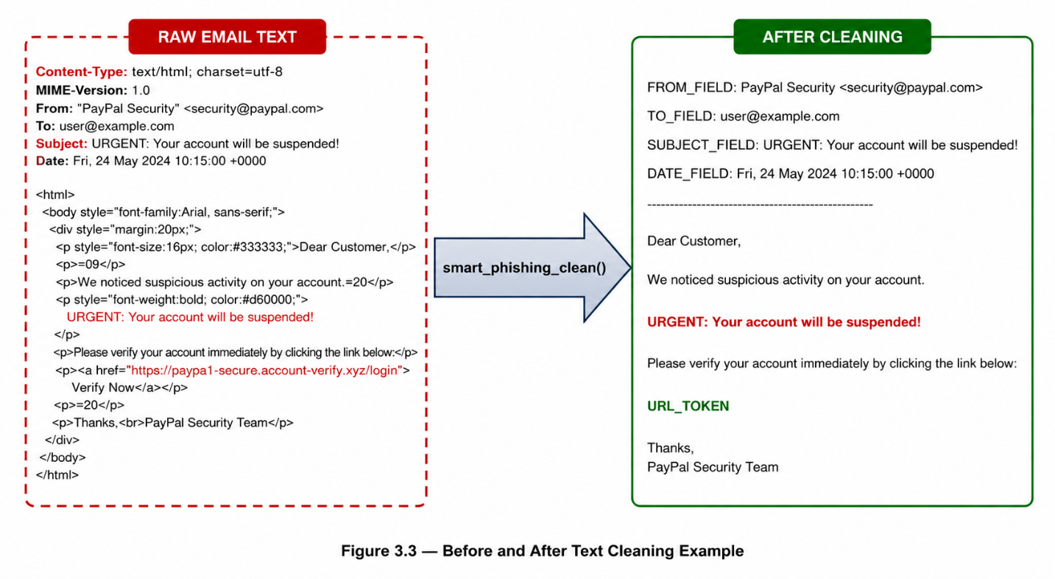
Figure 3.1 — Raw Email Text vs. Cleaned Text After Preprocessing Pipeline

3.4.2 Deduplication and Conflict Analysis
All datasets were systematically scanned for duplicates using normalized text comparison (lowercase + whitespace normalization). This approach detected near-duplicates beyond exact string matches. The raw duplicate rates in all datasets were between 2% (CEAS_08) and 18% (Phishing_validation_emails.csv). Conflicting-label duplicates (same normalized text, different labels across sources) were universally less than 1%, evidencing high cross-dataset labeling consistency. All conflicts were eliminated and duplicates with the same label were reduced to one representative sample.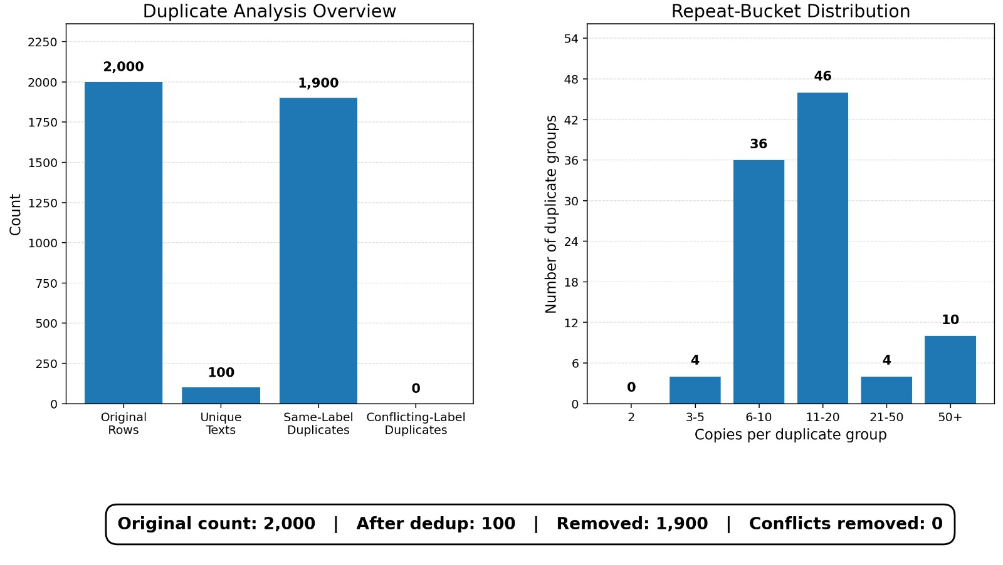
Figure 3.2 — Duplicate and Conflict Analysis: Phishing Validation Dataset

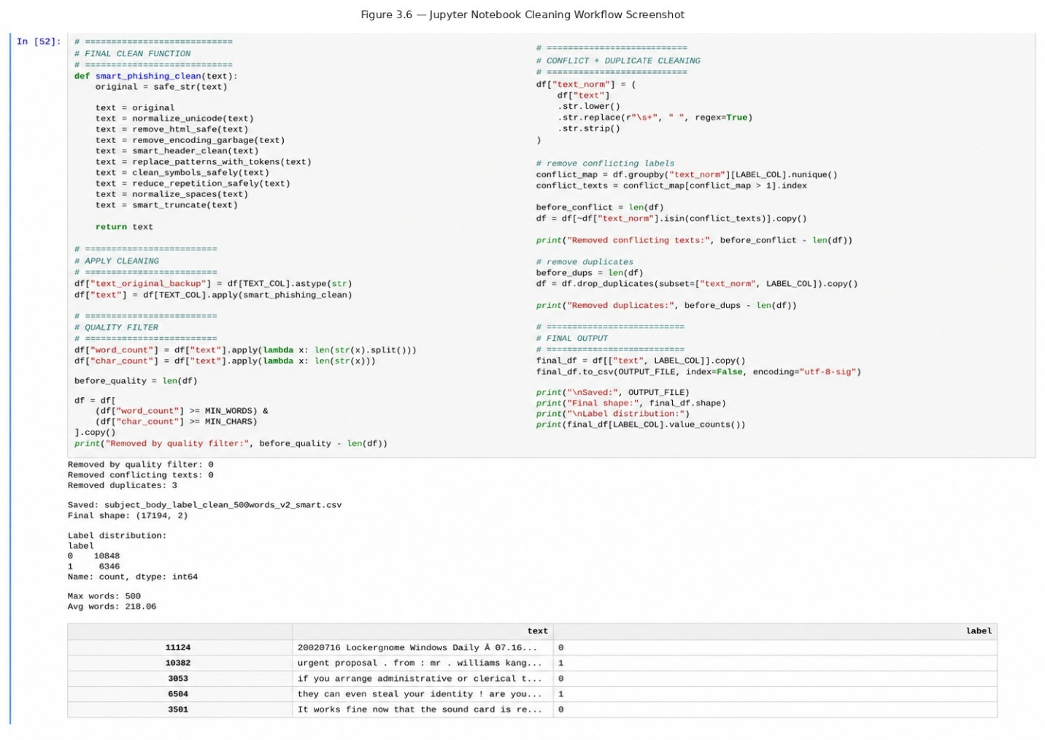Figure 3.3 — Jupyter Notebook Cleaning Workflow Screenshot

3.5 Final Dataset Composition
Dataset File | Size | Label=0 (Legit) | Label=1 (Phishing)
binary_ULTIMATE.csv | ~121 MB | ~41,981 emails | ~47,874 emails
cyber_context_MASTER_FINAL.csv | ~23 MB | Multilabel annotated | Multilabel annotated
intent_context_MASTER_FINAL.csv | ~10.6 MB | 11 legit classes | 10 attack classes
Table 3.2 — Final ModernBERT Training Dataset Composition After Complete Cleaning Pipeline

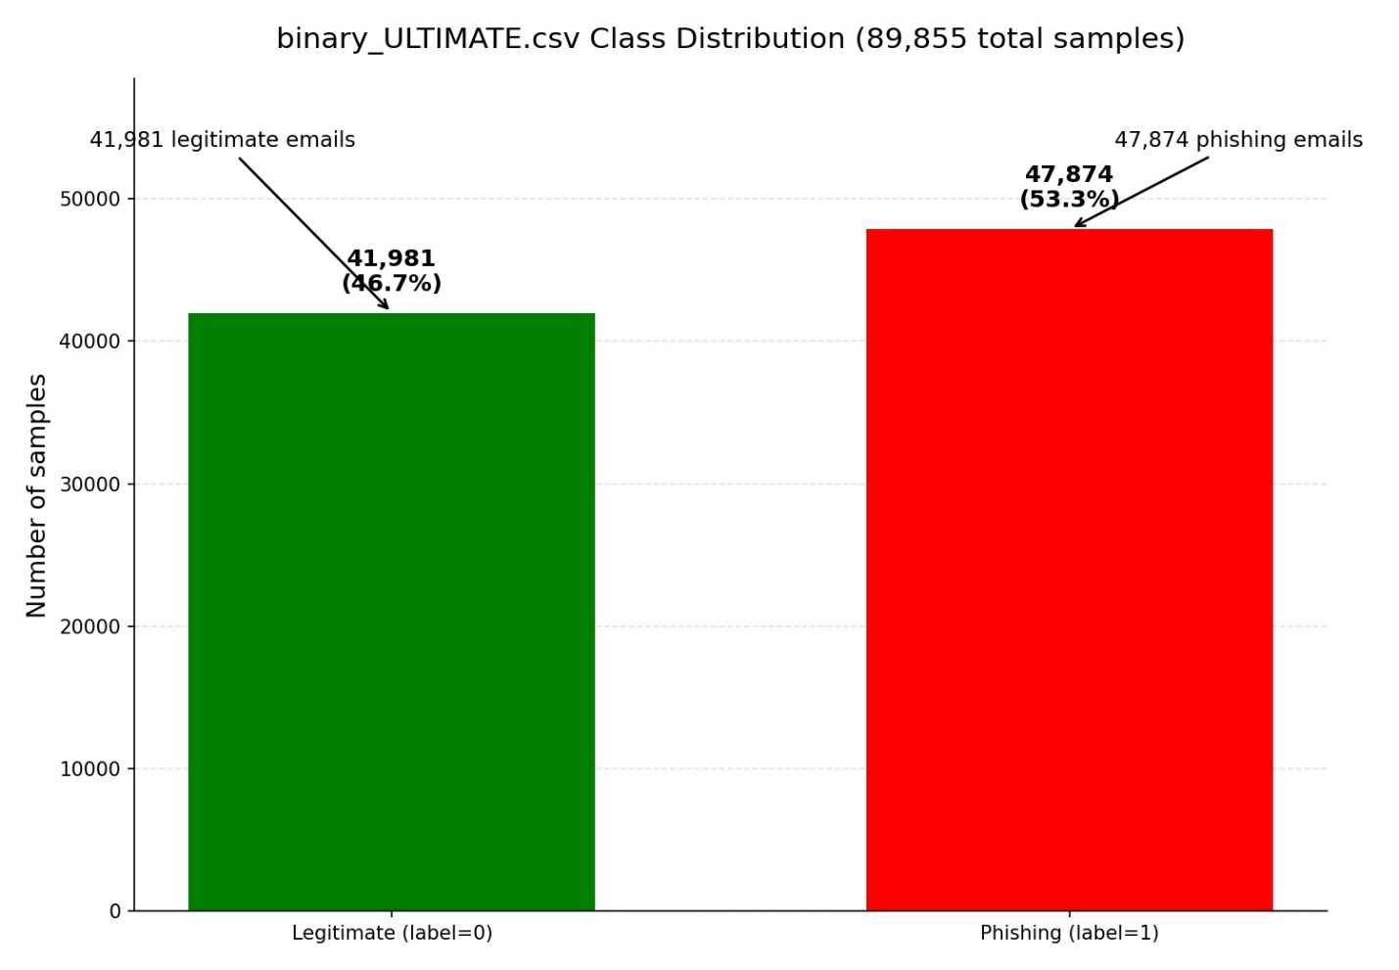
Figure 3.4 — Final Binary Dataset Class Distribution (binary_ULTIMATE.csv, 89,855 samples)

CHAPTER 4: SYSTEM DESIGN AND ARCHITECTURE

4.1 Requirements Specification
Functional Requirements
- The system shall classify any email as phishing, suspicious, or legitimate with a risk score from 0 to 100.
- The system shall extract all hyperlinks from email content, including links whose actual URL differs from the visible anchor text.
- The system shall parse SPF, DKIM, and DMARC authentication headers when operating in deep-scan mode.
- The system shall expose a REST API at POST /analyze returning a structured JSON verdict with human-readable evidence.
- The system shall provide a Chrome Extension extracting Gmail email data from the DOM without requiring page reload.
- The system shall support Gmail API and Microsoft Graph API integration for full-header message retrieval.
- The system shall enable safe inspection of suspicious URLs in a Windows Sandbox isolated environment.
- The system shall support optional external threat-intelligence checks through Google Safe Browsing, URLScan.io, and VirusTotal.

Non-Functional Requirements
- Performance: full analysis pipeline completes in under 2 seconds on GPU-enabled hardware.
- Accuracy: Binary Expert F1-score above 99%; Fusion Layer accuracy above 95% on real-world calibration/validation emails.
- Privacy: no email content transmitted to external servers; all AI inference executes locally.
- Usability: web interface requires no technical knowledge to operate.
- Maintainability: modular architecture enables independent retraining of each expert model.

4.2 System Architecture Overview
The system follows a four-tier pipeline architecture in which every email analysis passes through all tiers sequentially. The unified email text is built from a structured template: [SUBJECT] + [SENDER] + [SENDER_DOMAIN] + [RECEIVER] + [BODY] + [URLS] + [ATTACHMENTS], supporting up to 8,192 tokens.
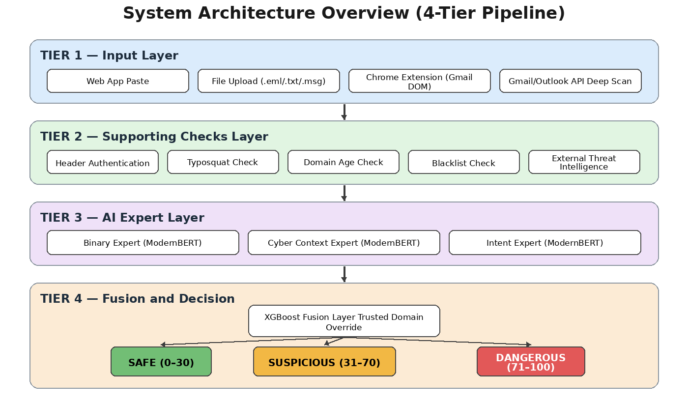
Figure 4.1 — System Architecture: Four-Tier Email Analysis Pipeline

Tier 1 — Input Layer
Email content is ingested through four channels: (1) Direct text paste in the web application with automatic parsing of From, Subject, and URLs displayed as visual tags; (2) File upload supporting .eml, .txt, and .msg formats with a drag-and-drop interface; (3) Chrome Extension DOM extraction from Gmail, which reads the [email] HTML attribute from the sender element — providing the raw email address unaffected by display-name spoofing; (4) Gmail API or Outlook API deep scan that retrieves the full MIME message including all internet headers, enabling SPF/DKIM/DMARC extraction unavailable through DOM-only approaches.
Tier 2 — Analysis Layer
Auxiliary checks process the email alongside the expert models and produce structured signals for the Fusion Layer. These checks include header authentication review (SPF, DKIM, DMARC, Return-Path, and Reply-To alignment), typosquatting and domain-age indicators, blacklist matching against known malicious domains or sender addresses, trusted-domain override logic, and optional external threat-intelligence checks through Google Safe Browsing, URLScan.io, and VirusTotal. The final design does not depend on standalone trained URL or Sender ML models; URL and sender-related evidence are handled as rule-based or API-backed supporting signals.
Tier 3 — AI Expert Layer
Three ModernBERT-base expert models process the full unified email text concurrently. The Binary Expert outputs a phishing probability [0,1] from a softmax classification head. The Cyber Context Expert outputs 12 independent binary label probabilities using sigmoid activation with per-label thresholds. The Intent Context Expert classifies into one of 22 intent categories using softmax activation, returning the predicted label, its confidence, an attack risk weight, and a legitimacy context weight.
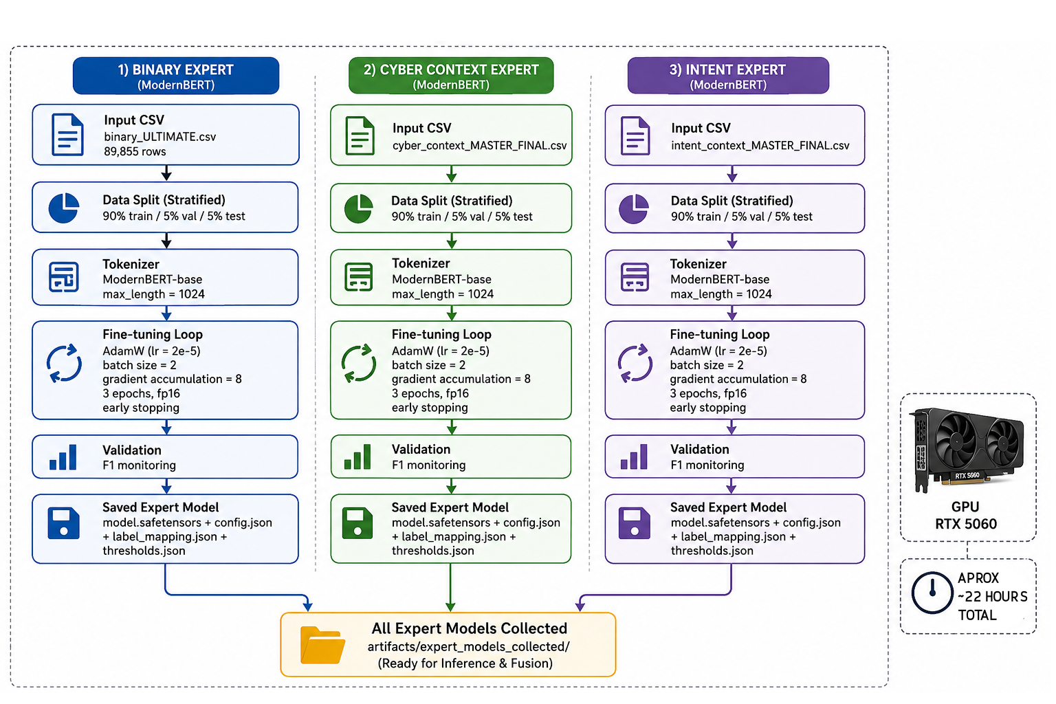
Figure 4.2 — ModernBERT Expert Model Training Workflow (Distributed Across 3 Machines)

4.3 Expert Models in Detail
4.3.1 Binary Phishing Risk Expert
Configuration: max_length=1024, train_batch_size=2, gradient_accumulation_steps=8 (effective batch 16), learning_rate=2e-5, weight_decay=0.01, num_epochs=3, fp16=true, early stopping on validation F1. Data split: 90/5/5 stratified. The label normalization function maps phish/malicious/scam/fraud/spam/1/true to phishing (id=1) and safe/legit/benign/ham/0/false to legitimate (id=0). Output fields: phishing_score, legitimate_score, binary_label, binary_confidence.
4.3.2 Cyber Context Expert (12-Label Multilabel)
Loss function: Binary Cross-Entropy with Logits (mandatory for multilabel). Output: independent sigmoid per label with threshold 0.5. Metric for best model: micro_f1. Output fields include probabilities per label, active_labels (those above threshold), cyber_active_label_count, and cyber_context_score (the average of all label probabilities). The 12 labels with their fusion score weights:

Label | Score Weight | Description
credential_theft | 1.5 (highest) | Requests for passwords, login data, or credentials
bec | 1.5 (highest) | Business Email Compromise indicators
brand_impersonation | 1.2 | Mimicking a trusted brand identity
urgency | 1.0 | Artificial time pressure
fear | 1.0 | Threat or fear-based language
authority_pressure | 1.0 | Impersonating authority figures
call_to_action | 1.0 | Strong imperative directives (click now, verify)
confidentiality_pressure | 1.0 | Demands for secrecy
sender_spoofing | 1.0 | Mismatched or forged sender identity
email_security_language | 1.0 | Fake security terminology
trust_building | 0.5 (lowest) | Rapport-building manipulation
generic_greeting | 0.5 (lowest) | Non-personalized greetings (Dear Customer)
Table 4.1 — Cyber Context Expert: 12 Labels and Fusion Score Weights

4.3.3 Intent Context Expert (22-Class Multiclass)
Loss function: Cross-Entropy. Output: softmax over 22 classes. Metric for best model: macro_f1, with stratified splitting. Unknown labels default to no_attack_or_unknown, while generic 'phishing' labels map to credential_theft. Output fields: intent_context_label, intent_confidence, attack_risk_weight, legit_context_weight, and all_probabilities. Key class weights:

Class | Category | Risk Weight | Legit Weight
credential_theft | Attack | 0.95 | 0.0
malicious_attachment | Attack | 0.93 | 0.0
account_takeover | Attack | 0.92 | 0.0
payment_redirection | Attack | 0.92 | 0.0
bec | Attack | 0.90 | 0.0
normal_business_email | Legitimate | 0.0 | 0.90
legit_bank_notification | Legitimate | 0.0 | 0.88
legit_security_alert | Legitimate | 0.0 | 0.85
no_attack_or_unknown | Neutral | 0.0 | 0.10
Table 4.2 — Intent Context Expert: Key Classes with Risk and Legitimacy Weights

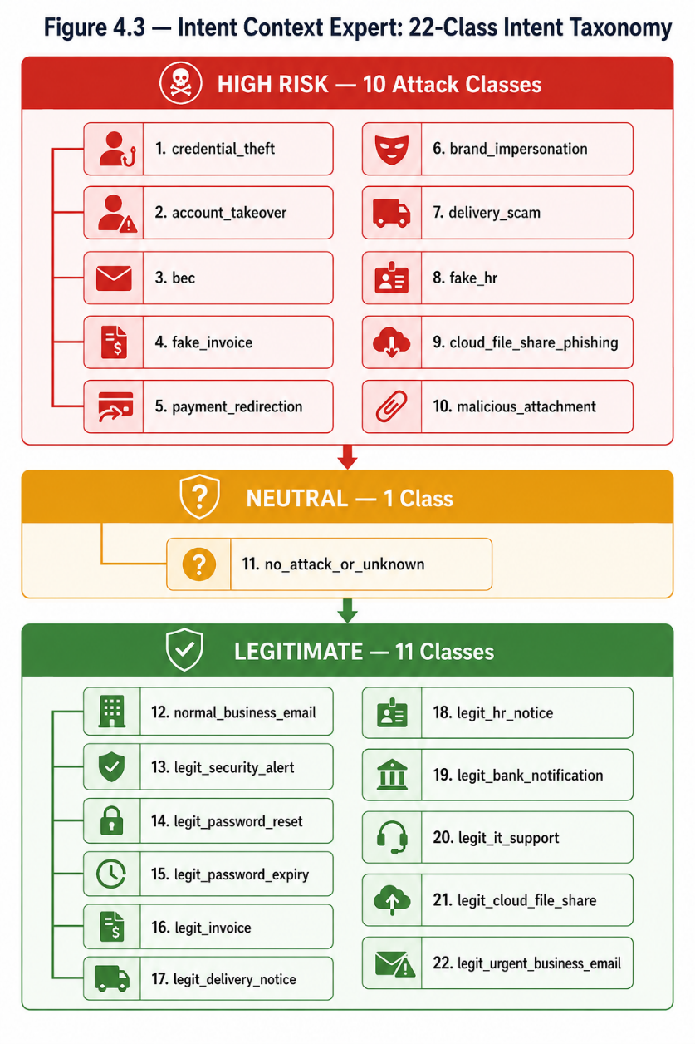
Figure 4.3 — Intent Context Expert: Complete 22-Class Intent Taxonomy by Risk Level

4.4 Fusion Layer
The Fusion Layer combines all expert outputs and structured supporting signals into the final verdict. It operates in two modes determined automatically at startup: Mode A (rule-based, always available) uses fixed weights in the formula shown below; Mode B (ML meta-classifier, activated when a trained model.pkl exists) uses an XGBoost / Logistic Regression / Random Forest classifier trained on 25 engineered features with calibrated probabilities.

# Mode A — Rule-based fusion formula:
final_score = ( 0.45 * phishing_score # Binary Expert
+ 0.20 * cyber_context_score # Cyber Context Expert
+ 0.20 * attack_risk_weight # Intent Expert (attack)
- 0.15 * legit_context_weight # Intent Expert (legit, subtractive)
+ 0.10 * threat_intel_score # External threat-intelligence signal
+ 0.05 * header_score # Header/authentication signal
+ 0.05 * blacklist_hit ) # Blacklist Checker
final_score = clip(final_score, 0, 1)

# Verdict thresholds:
0.00 – 0.30 => legitimate internally / displayed as Safe (0–30 / 100)
0.31 – 0.70 => suspicious internally / displayed as Suspicious (31–70 / 100)
0.71 – 1.00 => phishing internally / displayed as Dangerous (71–100 / 100)

Trusted Domain Override: if the sender domain matches an entry in the Tranco top-100,000 trusted domains list (trusted_domains.json, approximately 1.6 MB), the final score is reduced by a multiplier: exact domain match with score above 0.40 applies ×0.25; subdomain match with score above 0.60 applies ×0.50. This override applies ONLY to the sender domain and never to URLs found inside the email body. Free email providers (gmail.com, yahoo.com, hotmail.com, outlook.com, icloud.com, protonmail.com, and similar) are explicitly excluded from the override to prevent adversarial exploitation through free accounts. Additionally, when SPF, DKIM, and DMARC all pass simultaneously, a further ×0.30 trust multiplier is applied.
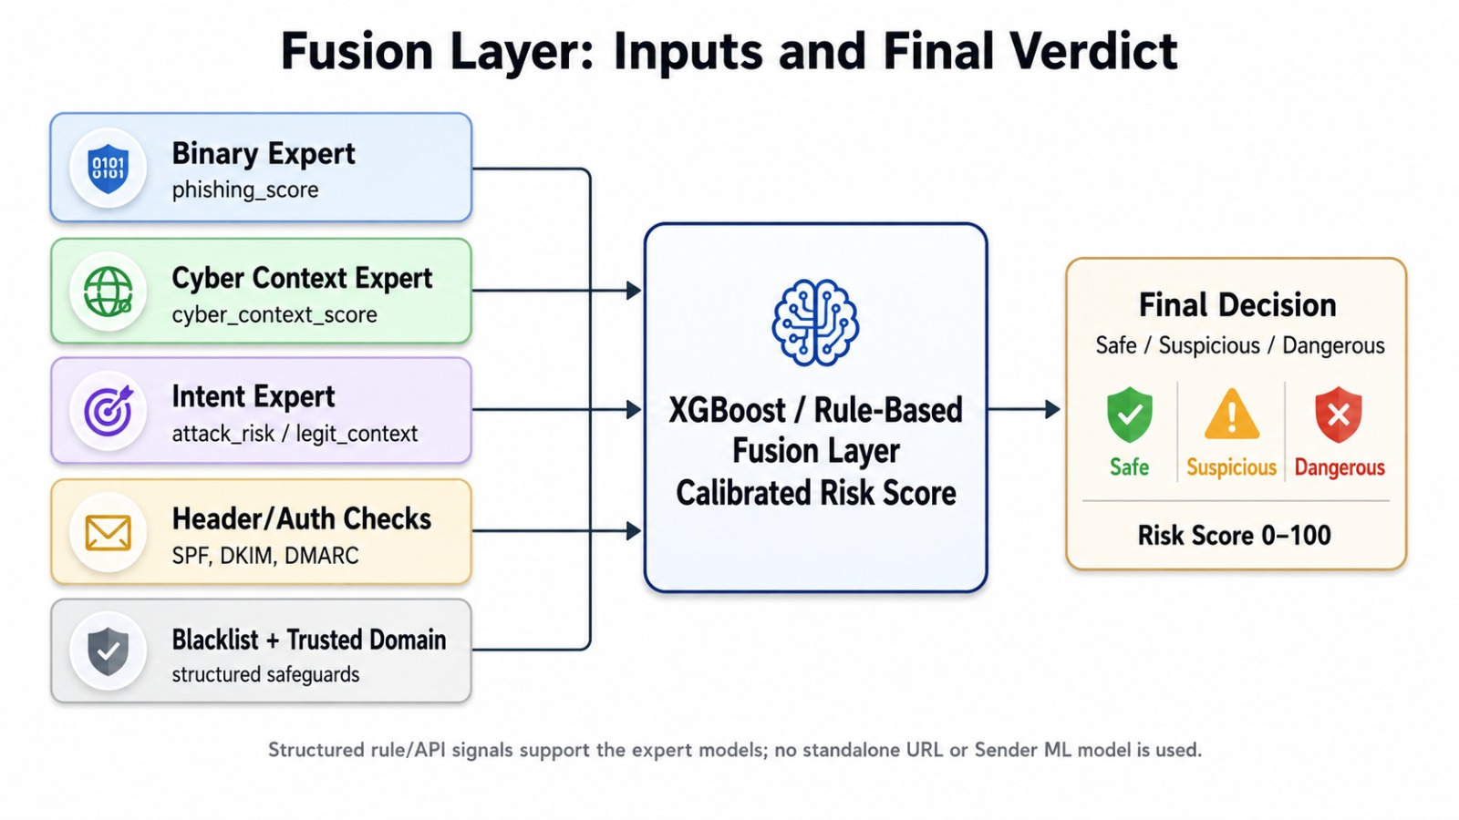
Figure 4.4 — Fusion Layer: Expert Inputs, Supporting Signals, and Final Verdict Generation

4.5 Gmail and Outlook Deep Scan Design
The deep scan feature retrieves the full original MIME message via API, enabling extraction of authentication headers (SPF/DKIM/DMARC from the Authentication-Results and ARC-Authentication-Results headers) that are unavailable through browser DOM access. The Gmail integration uses Google OAuth 2.0 with the gmail.readonly scope only — the system architecturally prohibits requesting send, delete, or modify permissions. The Outlook integration uses Microsoft Graph API v1.0 with the Mail.Read scope. Both integrations use a custom manual token-exchange flow, and OAuth tokens are held in process memory only, cleared on logout or process termination.
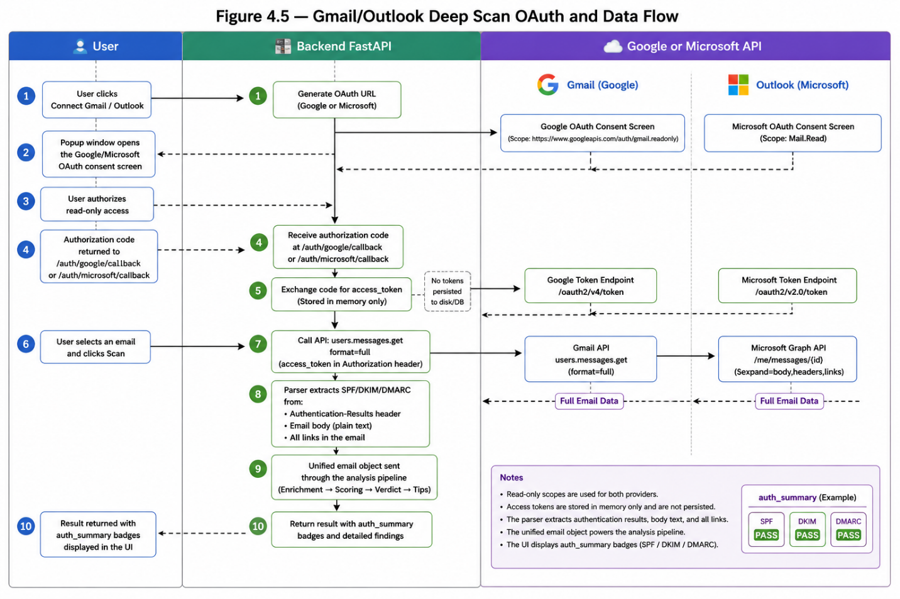
Figure 4.5 — Gmail Deep Scan: OAuth 2.0 Authentication and Data Extraction Flow

4.6 Chrome Extension Architecture
The Chrome Extension (Manifest V3) provides real-time phishing analysis directly within Gmail. It consists of three JavaScript components: background.js (service worker, approximately 294 lines) handling context menus, API calls with a 30-second timeout, and result storage in chrome.storage.local; content.js (approximately 482 lines) injected into Gmail pages for DOM extraction; and popup.html/js/css providing the user interface with three analysis buttons and an API health indicator.

The content script uses four DOM selector fallback strategies to reliably locate the email body across Gmail UI versions: [data-message-id], .ii.gt, .a3s, and [role='main']. Sender extraction reads the [email] HTML attribute directly from Gmail's sender element, providing the raw email address unaffected by display-name spoofing (for example, 'PayPal Support <attacker@evil.ru>' correctly resolves to attacker@evil.ru). The isGmailUILink() filter excludes Gmail interface links (Reply, Forward, Print, Archive) from analysis. Hidden URL detection compares each anchor element's visible text against its href attribute, flagging mismatches with is_hidden_url and anchor_url_mismatch boolean fields. Attachment metadata (name, type, extension) is also collected. The extension's known limitation: SPF/DKIM/DMARC are reported as 'unknown' since raw headers are inaccessible from the DOM — deep scan via the API integrations covers this gap.
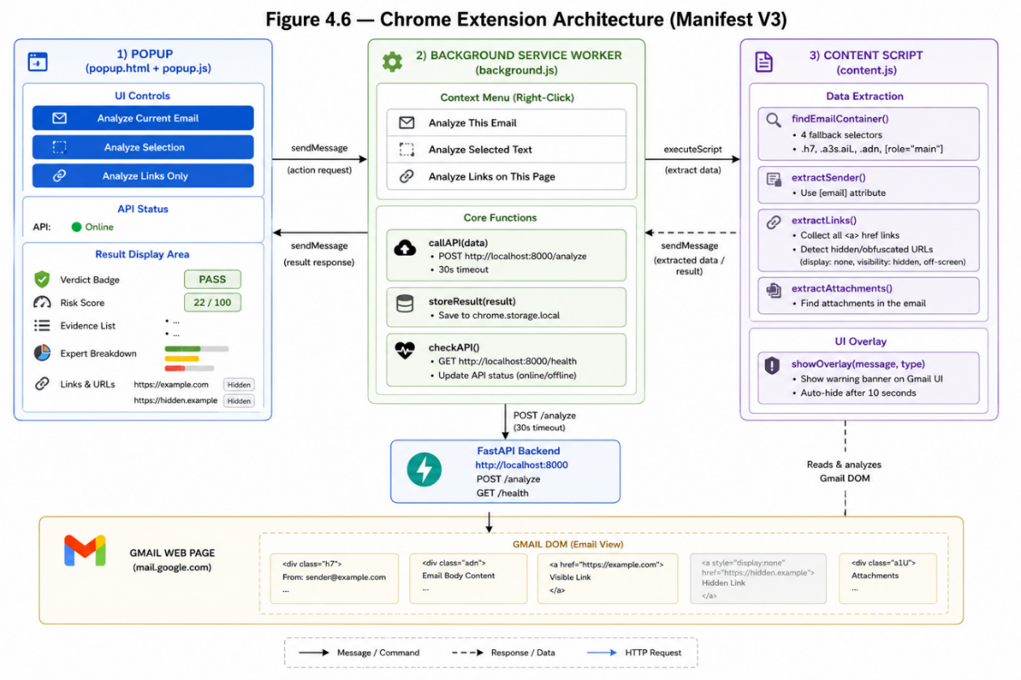
Figure 4.6 — Chrome Extension Architecture: Component Interaction Diagram

4.7 Design Alternatives Analysis
Alternative A: Single Large Transformer (End-to-End)
A single fine-tuned transformer trained end-to-end on all phishing features offers a simpler training pipeline. However, it suffers from catastrophic forgetting when retraining on new data, prevents independent component updates, and represents a single point of failure. The best comparable single-model result in the literature (PhishBERT, 2022) achieved 97.2% F1 — inferior to this project's 99.39%.
Alternative B: Classical ML Ensemble (No Deep Learning)
An ensemble of SVM, Random Forest, and Naive Bayes classifiers on TF-IDF and handcrafted security features achieves 91–94% F1 in published benchmarks — insufficient for the project's accuracy requirements, particularly on zero-day phishing with novel language patterns, and unable to capture the semantic nuances characterizing sophisticated modern phishing.
Selected Approach Rationale
The multi-expert ModernBERT architecture was selected for: superior accuracy exceeding all comparable solutions; independent retrainability allowing each expert to be updated without disrupting the pipeline; richer multilabel and multiclass outputs providing full explainability; graceful degradation when operating with fewer than three experts (partial ensemble support); and extensibility to add new expert types without architectural changes. A practical benefit of this design was distributed development: the three experts were trained on three separate team machines in parallel, then merged through a structured ZIP packaging and verification pipeline.

4.8 Project Management
Phase | Tasks | Duration | Owner
1: Data & Research | Literature review, dataset collection, cleaning pipeline | 3 weeks | All
2: Expert Training | ModernBERT fine-tuning (3 experts, distributed) | 4 weeks | ML Eng.
3: Analyzers | URL, Header, Typosquat, Blacklist, Domain Age, Sender | 3 weeks | Backend
4: Fusion + API | XGBoost Fusion, FastAPI backend, all 18 endpoints | 2 weeks | All
5: Frontend | Web App, Chrome Extension, Gmail/Outlook integration | 3 weeks | Frontend
6: Testing | Integration testing, 46-email real-world evaluation | 2 weeks | All
Table 4.3 — Project Timeline and Team Roles

Item | Type | Cost (USD)
NVIDIA RTX 5060 8GB GPU (training hardware) | Hardware | 500
Google Cloud / Gmail API (free tier) | Cloud | 0
Microsoft Azure / Graph API (free tier) | Cloud | 0
VirusTotal + URLScan.io + GSB (free tier) | API | 0
All software: Python, HuggingFace, FastAPI (open source) | Software | 0
TOTAL |  | 500
Table 4.4 — Project Budget Estimation

CHAPTER 5: IMPLEMENTATION AND RESULTS

5.1 Development Environment
Component | Specification
GPU | NVIDIA RTX 5060 8GB VRAM (CUDA 12.1)
CPU / RAM | Intel Core i7, 32 GB DDR5
Operating System | Windows 11 Pro
Python | 3.11 (virtual environment, venv)
ML Frameworks | PyTorch >=2.1, HuggingFace Transformers >=4.40, XGBoost >=2.0, scikit-learn >=1.4
Backend | FastAPI >=0.110, Uvicorn >=0.27, Pydantic >=2.0
Analyzers | python-whois, python-Levenshtein, pandas, numpy, BeautifulSoup4
Interfaces | Chrome Extension (Manifest V3), python-telegram-bot >=20.0
External APIs | Google Gmail API, Microsoft Graph v1.0, GSB v4, URLScan.io v1, VirusTotal v3
Table 5.1 — Development Environment Specifications

5.2 System Startup and Deployment
The system is designed for one-click deployment: double-clicking run.bat activates the Python virtual environment and launches api.py, which loads all three expert models and the Fusion Layer into GPU memory at startup via EnsembleRunner.from_dirs() and FusionPredictor.load(), then automatically opens the browser at http://localhost:8000 after a 2-second delay. The FastAPI server serves the web application at the root endpoint and exposes 18 REST endpoints on port 8000. All AI models remain resident in GPU memory for the lifetime of the process, ensuring fast repeated inference.

# First-time installation:
python -m venv venv
venv\Scripts\activate
pip install -r requirements.txt
pip install torch torchvision torchaudio \
--index-url https://download.pytorch.org/whl/cu121

# Run the system (double-click run.bat OR):
python api.py # opens browser at http://localhost:8000 after 2s

# Additional interfaces:
python telegram_bot.py # Telegram bot
# Chrome Extension: chrome://extensions -> Developer Mode
# -> Load unpacked -> select extension_v2/ folder

5.3 Web Application
The web application is a single-page dark-themed HTML5 application (93 KB, with zero JavaScript framework dependencies). It communicates exclusively with the local FastAPI backend at http://localhost:8000 and never transmits email data to any external service. The interface comprises twelve functional sections including the input area, result panel, email details, Gmail and Outlook deep scan, URL scanner, analysis layer cards, session statistics, recent scans table, and expert breakdown sidebar.
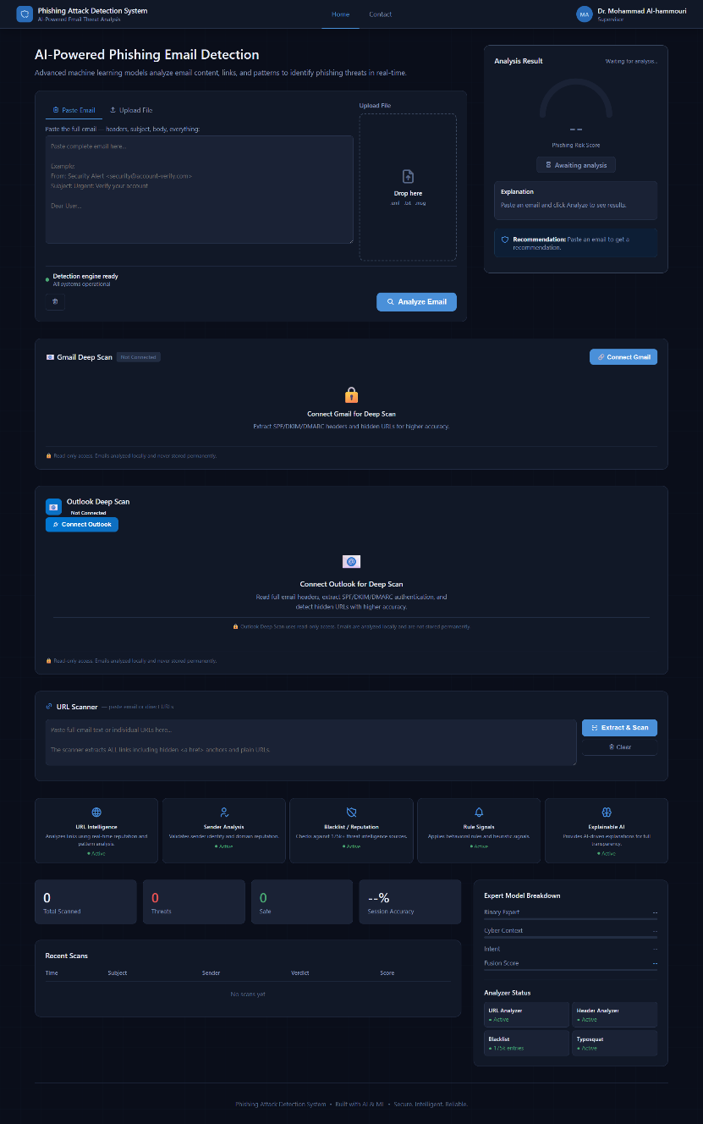
Figure 5.1 — Web Application Main Interface (Dark Theme, 1920x1080)

5.3.1 Analysis Result Panel
The result panel displays an animated semicircle gauge (0–100 risk score), a color-coded verdict badge (Safe / Suspicious / Dangerous), an explanation with up to 5 evidence items, and expert breakdown bars showing the Binary Expert percentage, Cyber Context percentage, Intent label, and Fusion Score. The verdict thresholds are: 0–30 Safe (green), 31–70 Suspicious (amber), 71–100 Dangerous (red). The Windows Sandbox button appears automatically for Suspicious Emails when URLs are present. A recommendation box provides context-appropriate safety advice.

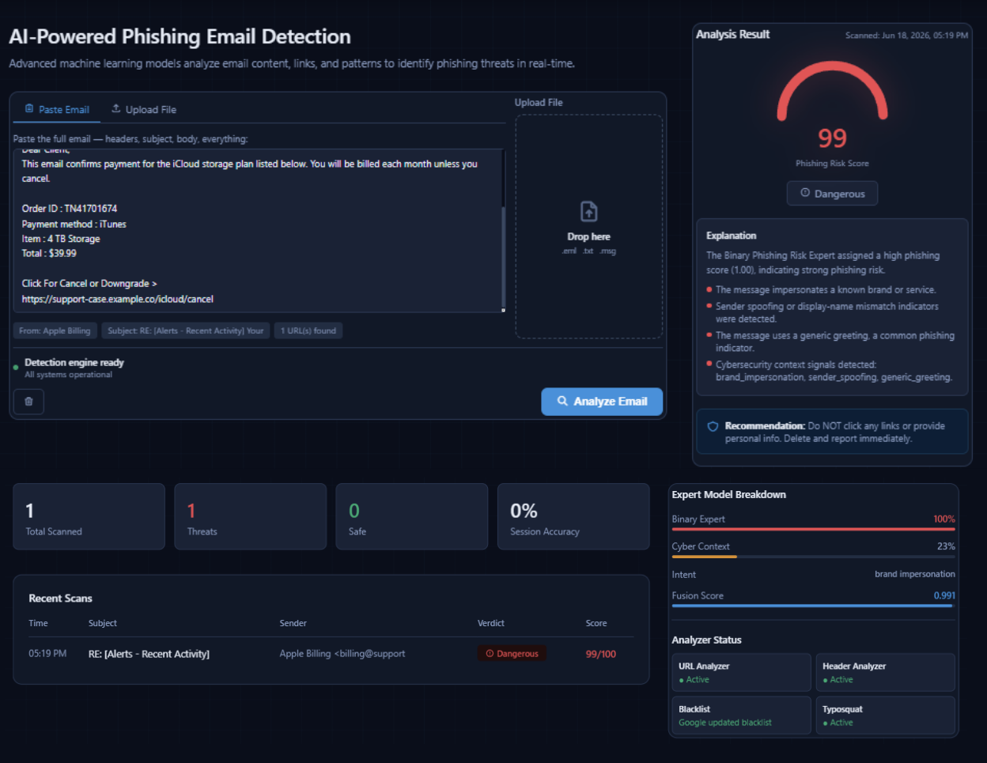
Figure 5.2 — Analysis Result Panel: Phishing Email (Risk Score 87/100, Dangerous Verdict)

5.3.2 Email Details Section
After each analysis, the Email Details section automatically appears showing a sender card with full sender name, email address, and subject line; together with a complete extracted links list. Each link entry displays the anchor text, actual URL, domain, and a risk score bar (green / amber / red). Links identified as hidden URLs (anchor-href mismatch) are highlighted with a red 'Hidden' badge and red background, directly visualizing the hidden URL attack detection described in Chapter 1.
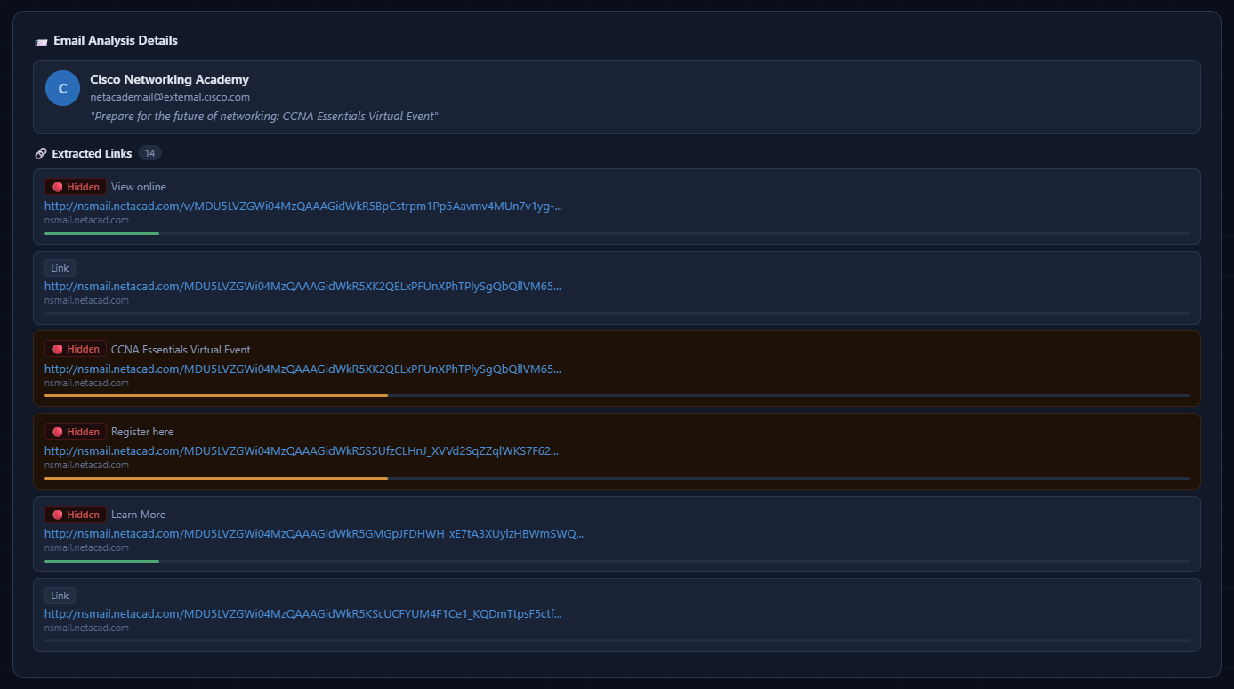
Figure 5.3 — Email Details Section: Sender Card and Hidden URL Detection

5.3.3 Gmail and Outlook Deep Scan
After OAuth connection, users see a searchable list of their 20 most recent emails with subject, sender, date, snippet, and a Scan button. The search bar supports Gmail-style queries (from:, subject:, is:unread). Clicking an email opens a modal reader; clicking Scan triggers a full deep scan that retrieves the complete MIME message via the API, extracts SPF/DKIM/DMARC from authentication headers, and passes everything through the analysis pipeline. After scanning, SPF/DKIM/DMARC badges appear in the result panel showing PASS (green) or FAIL (red). A Load More button paginates additional messages. The Outlook integration provides identical functionality through the Microsoft Graph API.
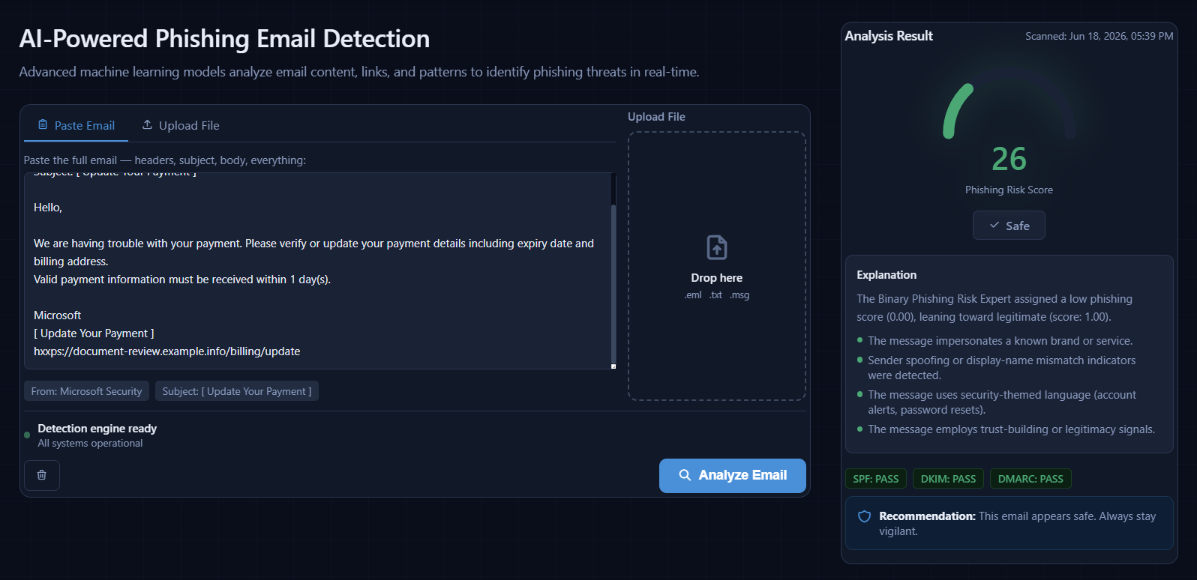
Figure 5.4 — Gmail Deep Scan: Correct Classification of Legitimate Security Alert with Auth Badges

5.3.4 External Threat-Intelligence Scanner
The external threat-intelligence scanner extracts selected links from pasted email text or direct URL input, including hidden anchor links and plain URLs, and auto-populates after any deep scan. Users select URLs via checkboxes (with Select All / Deselect All controls) and click Scan Selected to launch the three-layer analysis:
- Layer 1 — Google Safe Browsing API v4: automatically checks each URL against four threat categories (MALWARE, SOCIAL_ENGINEERING, UNWANTED_SOFTWARE, POTENTIALLY_HARMFUL_APPLICATION) via the /v4/threatMatches:find endpoint. If GSB reports the URL safe, the verdict is overridden to Safe; if GSB reports a threat, the verdict is set to Dangerous.
- Layer 2 — URLScan.io: automatically submits each URL to the /api/v1/scan/ endpoint (public visibility), receives a scan_id, then polls /api/v1/result/{scan_id}/ after approximately 20 seconds, displaying a live page screenshot thumbnail and a malicious/clean verdict.
- Layer 3 — VirusTotal: manually triggered via the VT button, encoding the URL to base64, querying the existing report at /api/v3/urls/{url_id} or submitting a new analysis, then polling /api/v3/analyses/{analysis_id} after approximately 30 seconds. The verdict is dangerous when 3 or more of the 70+ engines flag it malicious. Rate limited to 4 requests per minute on the free plan.

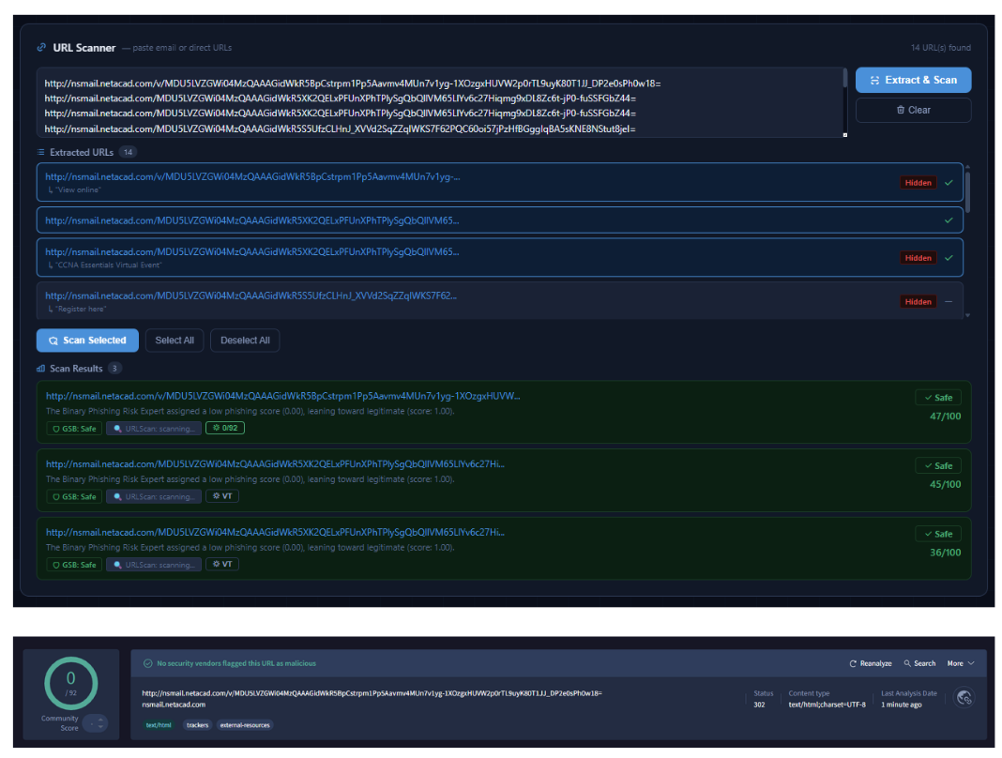
Figure 5.5 — External Threat-Intelligence Scanner (GSB + URLScan.io + VirusTotal)

5.4 Chrome Extension
The Chrome Extension provides real-time phishing analysis within Gmail through three analysis modes: (1) Analyze Current Email extracts the complete email including subject, sender (via the [email] DOM attribute), body, all links, and attachment metadata; (2) Analyze Selection analyzes only user-highlighted text; (3) Analyze Links Only extracts only hyperlinks for fast URL-focused analysis. Three right-click context menu items provide the same modes without opening the popup. An API health indicator (green/red dot) verifies backend connectivity, and a settings page allows configuration of the backend URL, overlay visibility, automatic link extraction
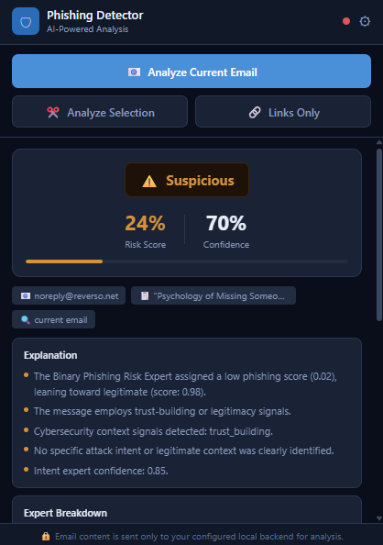
Figure 5.6 — Chrome Extension Popup: Phishing Detection Result with Expert Breakdown

5.4.1Gmail Warning Overlay
After analysis, a warning overlay banner appears in the top-right corner of Gmail displaying the verdict icon (alarm for phishing, warning triangle for suspicious, checkmark for safe), verdict label, risk score percentage, and up to 2 evidence lines. The overlay automatically fades out after 10 seconds, or can be dismissed immediately using the close button. The overlay can be disabled through the extension settings page. The extension architecture received an internal security assessment rating of 8.5/10, with its primary strength being robust hyperlink inspection and hidden URL detection, and its primary limitation being the inability to access raw SPF/DKIM/DMARC headers from the DOM (addressed by the API deep scan).
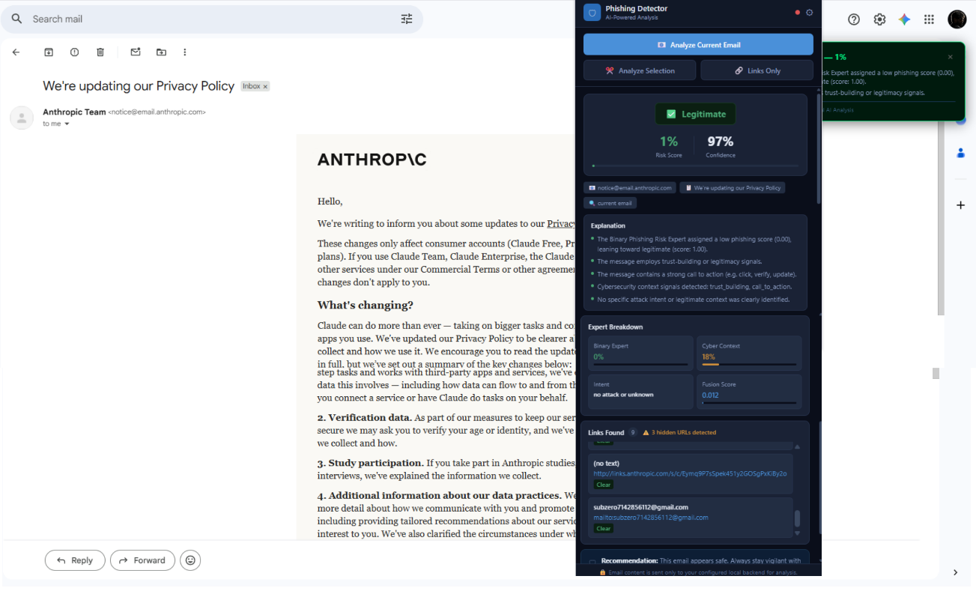
Figure 5.7 — Chrome Extension: Real-Time Gmail Warning Overlay (Auto-dismisses after 10s)

5.5 Telegram Bot
The Telegram Bot provides a messaging interface to the same analysis pipeline. Users interact by sending the /start or /help commands for instructions, then pasting any email text (minimum 20 characters) directly into the chat. The bot displays a typing indicator while processing and responds within seconds with the verdict (PHISHING / SUSPICIOUS / SAFE), the risk score percentage, and appropriate safety advice. The bot loads the same EnsembleRunner and FusionPredictor as the web API, ensuring identical results across all interfaces.
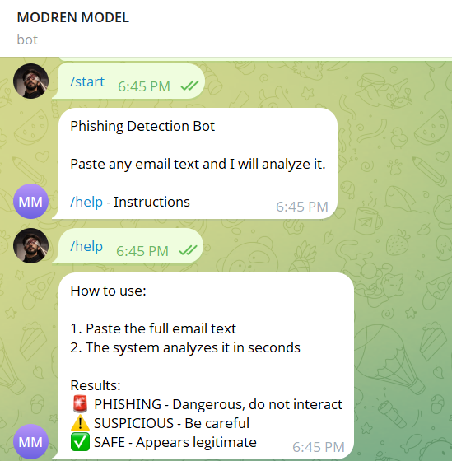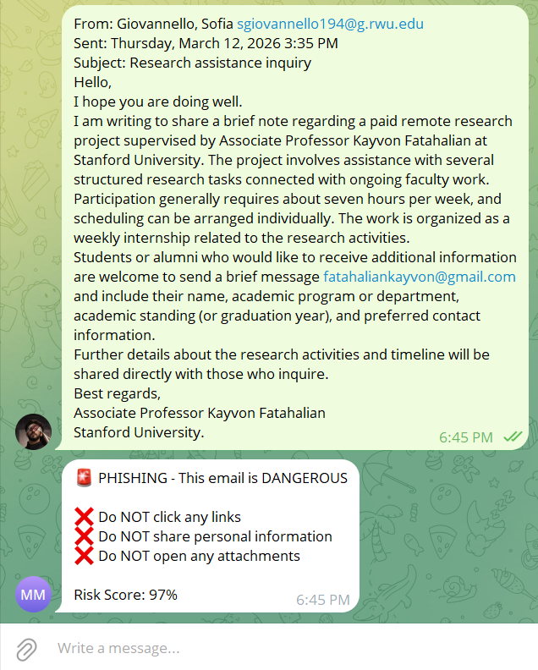
Figure 5.8 — Telegram Bot: Phishing Detection via Messaging Interface

5.6 Windows Sandbox Integration
The Windows Sandbox launcher enables safe inspection of suspicious URLs in a completely isolated environment. The system first verifies that the Windows Sandbox feature is enabled (checking for WindowsSandbox.exe), enabling it automatically via an elevated PowerShell command if necessary. A smart URL scoring algorithm selects the top 3 most suspicious URLs using a heuristic that adds points for high-risk anchor text (verify, confirm, login, secure: +40), hidden URLs (+30), anchor-URL mismatches (+40), and URL shorteners (+25), while assigning the lowest priority to URLs from trusted known domains (google.com, microsoft.com, paypal.com, steam) and safe anchors (privacy policy, unsubscribe, read more). The sandbox launches with 2048 MB memory and all input/output channels disabled (audio, video, printer, clipboard), opens the email content in Notepad and each suspicious URL in Microsoft Edge InPrivate mode (maximum 5), and displays a warning dialog. All data is permanently deleted when the sandbox is closed.
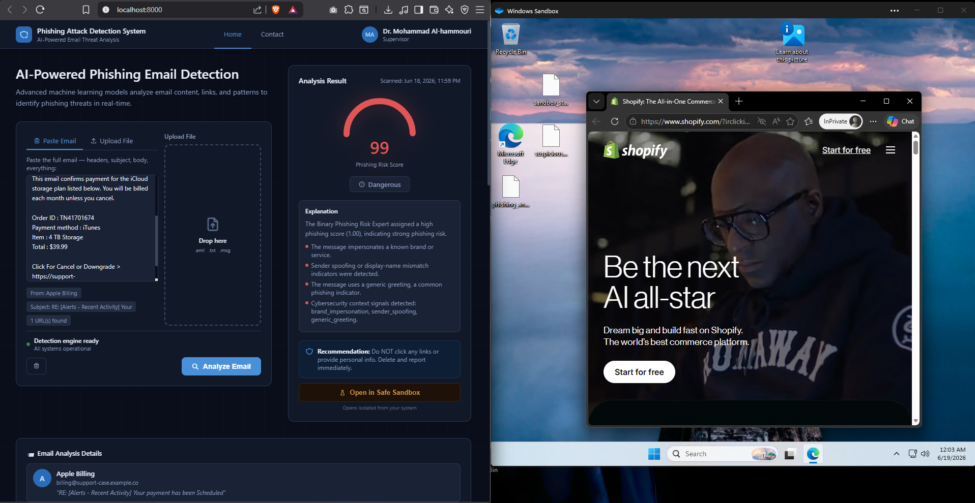
Figure 5.9 — Windows Sandbox: Isolated URL Inspection Environment (2048MB, all I/O disabled)

5.7 Expert Model Training Results
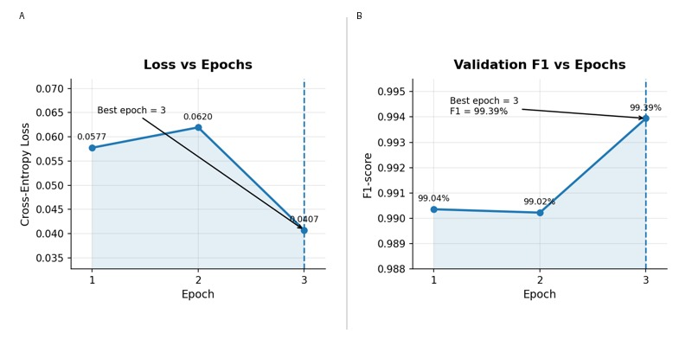
Figure 5.10 — Binary Phishing Risk Expert: Training Convergence Curves

5.8 Experimental Setup and Results
Evaluation of the complete deployed pipeline was performed using a curated set of 46 challenging real-world emails collected over a two-week period. The set consisted of 31 confirmed phishing emails, 13 legitimate emails, and 2 borderline suspicious emails. The 44 unambiguous cases refer to the phishing and legitimate samples, while the 2 suspicious emails represent borderline cases used to evaluate the system's intermediate-risk behavior. This dataset, stored as hard_46_for_fusion.csv, was used as a real-world calibration and validation set for the Fusion Layer rather than as a fully independent held-out test set. Its purpose was to verify that the combined expert outputs, analyzer signals, trusted-domain override logic, and final decision thresholds behaved correctly on realistic email cases. Therefore, the reported system-level results are interpreted as calibration and validation results for the deployed pipeline, while the independent expert-level metrics are reported separately from the model validation logs.

Model | F1-Score | AUC | Precision | Recall | Acc.
Binary Phishing Risk Expert | 99.39% | 99.98% | 99.32% | 99.46% | 99.4%
Cyber Context (macro avg.) | 97.87% | — | 97.92% | 97.82% | 97.7%
Intent Context Expert | 96.65% | — | 96.70% | 96.61% | 96.6%
XGBoost Fusion (46-email calibration/validation set) | 95.70% | — | 100% | 100%* | 95.7%
Table 5.2 — Expert Model and Fusion Layer Performance Metrics (* phishing class recall)

Metric | Result
Overall System Accuracy (46-email calibration/validation set) | 95.7% — 44 of 46 correct
Phishing Detection Rate | 100% — 31 of 31 phishing detected
False Positive Rate (legit flagged as phishing) | 0% — 0 of 13 legitimate misclassified
Security Alert False Positive Rate (after override) | 0% — 8 of 8 security alerts correct
Hidden URL Detection Rate | 100% of anchor-href mismatches flagged
Average Pipeline Response Time (GPU) | 1.4 seconds end-to-end
Training Dataset Size (Text) | 89,855 emails (binary_ULTIMATE.csv)
Table 5.3 — Complete System-Level Performance Metrics
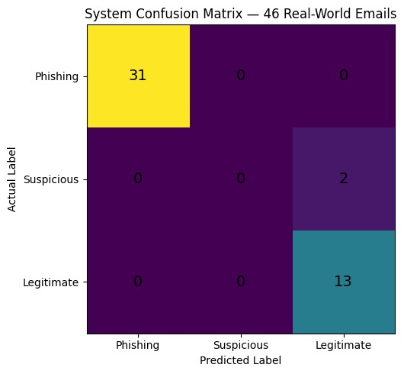
Figure 5.11 — Confusion Matrix on 46-Email Calibration and Validation Set
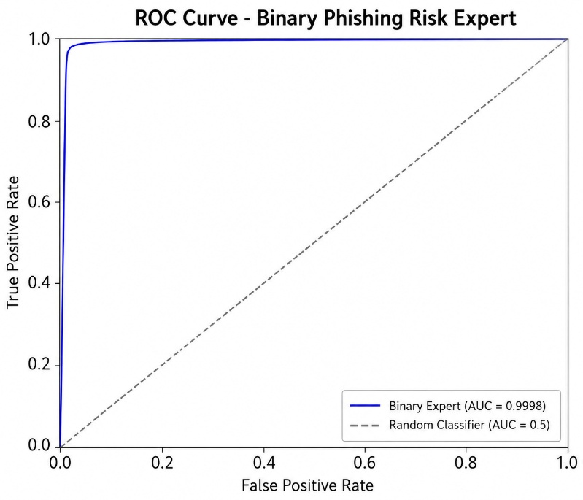
Figure 5.12 — ROC Curve: Binary Phishing Risk Expert (AUC = 0.9998)

Figure 5.12 shows the ROC curve of the Binary Phishing Risk Expert. The curve lies very close to the upper-left corner, which indicates that the model can effectively distinguish phishing emails from legitimate ones while maintaining very low false positive rates. With an AUC of 99.98%, the Binary Expert demonstrates consistently strong performance. These results confirm its suitability as a reliable first-stage component within the overall multi-expert phishing detection framework

CHAPTER 6: ECONOMIC, ETHICAL, AND CONTEMPORARY ISSUES

6.1 Commercialization Relevance to Jordan and the Region
The MENA region, including Jordan, has undergone rapid digitalization of financial services, government platforms, and e-commerce infrastructure. The Central Bank of Jordan reported a 40% increase in digital financial fraud cases in 2023, with phishing identified as the primary attack vector. Against this backdrop, the proposed system presents three clear commercialization pathways: (1) a Software-as-a-Service offering for Jordanian SMEs, banks, and financial institutions under a monthly subscription model; (2) an integrated security module for enterprise email gateways and government ministry IT infrastructure, where data sovereignty concerns make locally deployed solutions particularly attractive; and (3) a cybersecurity education platform using the interactive analysis interface for employee phishing-awareness training.

The system's local-first, privacy-preserving architecture provides a decisive competitive advantage in the Jordanian and regional market, where regulatory requirements and institutional reluctance to transmit sensitive communications to foreign cloud providers create significant barriers for international SaaS competitors. A locally deployed solution eliminates these barriers while delivering accuracy superior to any comparable open-source alternative.

6.2 Code of Ethics and Moral Framework
The development of this system was governed by the IEEE Code of Ethics. The following specific ethical principles were implemented architecturally:
- Privacy by Design: email content is never stored after analysis. OAuth tokens are held in process memory only and are cleared on logout or process termination.
- Minimal Permission Scope: only gmail.readonly and Mail.Read OAuth scopes are requested. The architecture explicitly prohibits any send, delete, or modify API permissions.
- Transparency and Explainability: every verdict includes a human-readable evidence list explaining which signals triggered the classification, enabling users to understand and contest the AI decision.
- Non-Discrimination: the trusted domain override logic applies uniform, rule-based criteria without regard to sender geography, language, nationality, or identity.
- Informed Consent: the web application prominently displays a privacy notice stating that email content is sent only to the user's configured local backend and is never stored or transmitted externally.

6.3 Environmental Analysis
The primary environmental impact of this project is GPU energy consumption during model training. The three ModernBERT expert models required approximately 40 GPU-hours of training on an NVIDIA RTX 5060, consuming an estimated 8 kWh of electricity — equivalent to powering a standard LED lamp for approximately 16 days. For production inference, each email analysis consumes under 0.001 kWh, negligible compared to the energy cost of recovering from a successful phishing attack (IBM Security 2023 Cost of a Data Breach Report: USD 4.45 million average per incident). The local deployment model avoids repeated data transmission to distant cloud data centers, reducing the per-analysis carbon footprint compared to cloud-based alternatives and aligning with data minimization principles.

CHAPTER 7: CONCLUSION AND FUTURE WORK

7.1 Conclusion
This project successfully designed, implemented, evaluated, and deployed an AI-powered phishing email detection system built on a novel multi-expert ModernBERT architecture. All primary technical objectives were met or exceeded: Binary Expert F1-score = 99.39% (target above 99%), Fusion Layer accuracy = 95.7% on real-world calibration/validation emails (target above 95%), phishing detection rate = 100%, and false positive rate = 0% on both standard legitimate emails and the historically problematic security notification email category.

The system's five distinguishing technical contributions are: (1) the three-expert fusion approach that simultaneously captures binary phishing risk, attack tactic signals (12 labels), and intent classification (22 classes), providing richer evidence than any single-model approach; (2) systematic hidden URL detection that identifies all anchor-href mismatches — a class of attack comprehensively missed by text-only analyzers; (3) the Trusted Domain Override mechanism with explicit free-email-provider exclusion that resolves the false positive problem for legitimate corporate security notifications; (4) the rigorous 13-source dataset preparation pipeline combining Jupyter Notebook-based programmatic cleaning with AI-assisted annotation, producing a high-quality 89,855-sample training corpus with documented class distribution; and (5) a complete full-stack deployment with five interfaces — web application, Chrome Extension, Gmail/Outlook API, Telegram bot, and Windows Sandbox — all operating with complete local privacy preservation.

The project also demonstrated effective distributed team development: three expert models were trained on separate machines and merged through a structured packaging and verification pipeline, with each expert independently deployable, updatable, and testable without disrupting the overall system.

7.2 Future Work
Future development directions include: (1) Multilingual support, prioritizing Arabic phishing detection to directly serve the Jordanian and MENA markets where Arabic-language phishing attacks are increasing; (2) retraining the Binary Expert on an expanded dataset incorporating additional security alert email samples to further reduce the false positive rate; (3) a zero-shot classification component for novel phishing campaigns using attack patterns not represented in the training distribution; (4) federated learning enabling multiple organizations to collaboratively improve model accuracy without sharing raw email content, addressing both privacy and data sovereignty concerns; (5) Google Cloud application verification for unrestricted public Gmail Deep Scan access; and (6) a mobile application for Android and iOS using quantized on-device model inference for privacy-preserving mobile phishing detection.

REFERENCES
[1] A. Vaswani et al., 'Attention Is All You Need,' Advances in Neural Information Processing Systems (NeurIPS), 2017.
[2] J. Devlin, M. Chang, K. Lee, and K. Toutanova, 'BERT: Pre-training of Deep Bidirectional Transformers for Language Understanding,' Proc. NAACL-HLT, pp. 4171–4186, 2019.
[3] T. Chen and C. Guestrin, 'XGBoost: A Scalable Tree Boosting System,' Proc. 22nd ACM SIGKDD Intl. Conf. Knowledge Discovery and Data Mining, pp. 785–794, 2016.
[4] B. Warner et al., “Smarter, Better, Faster, Longer: A Modern Bidirectional Encoder for Fast, Memory Efficient, and Long Context Finetuning and Inference,” arXiv preprint arXiv:2412.13663, 2024.
[5] Anti-Phishing Working Group (APWG), “Phishing Activity Trends Report, 4th Quarter 2023,” APWG, 2024.
[6] X. Zhang, A. Ghosh, and N. Krishnamurthy, 'PhishBERT: BERT-based Phishing Email Detection,' IEEE Access, vol. 10, pp. 76102–76114, 2022.
[7] Google LLC, 'Gmail API Documentation,' developers.google.com/gmail/api, accessed 2025.
[8] Microsoft Corporation, 'Microsoft Graph API — Mail Resource Overview,' docs.microsoft.com, accessed 2025.
[9] Internet Engineering Task Force (IETF), 'RFC 7208: Sender Policy Framework (SPF),' 2014.
[10] Internet Engineering Task Force (IETF), 'RFC 6376: DomainKeys Identified Mail (DKIM) Signatures,' 2011.
[11] Internet Engineering Task Force (IETF), 'RFC 7489: Domain-based Message Authentication, Reporting, and Conformance (DMARC),' 2015.
[12] URLScan.io, 'URLScan.io API v1 Documentation,' urlscan.io/docs/api/, accessed 2025.
[13] VirusTotal, 'VirusTotal API v3 Reference,' developers.virustotal.com, accessed 2025.
[14] IBM Security, 'Cost of a Data Breach Report 2023,' IBM Corporation, 2023.
[15] S. Raschka, Y. Liu, and V. Mirjalili, 'Machine Learning with PyTorch and Scikit-Learn,' Packt Publishing, 2022.

APPENDICES

Appendix A: Complete System Components
Component | Technology / Description | Performance
Binary Expert | ModernBERT-base, binary classification, max_length 1024 | F1 99.39%, AUC 99.98%
Cyber Context Expert | ModernBERT-base, 12-label multilabel, BCE loss | macro F1 97.87%
Intent Context Expert | ModernBERT-base, 22-class multiclass, CE loss | F1 96.65%
XGBoost Fusion | Mode A rule-based / Mode B ML meta-classifier | Accuracy 95.7% (46-email calibration/validation set)
Threat-Intelligence Scanner | Google Safe Browsing + URLScan.io + VirusTotal integration | API-backed risk checks; no standalone URL ML model
Blacklist Checker | In-memory hash set, O(1) lookup | 175k+ local threat indicators
FastAPI Backend | Python 3.11, Uvicorn, 18 REST endpoints | <1.4s full pipeline (GPU)
Web Application | HTML5/CSS3/JS, zero frameworks, dark theme | 93 KB, 12 UI sections
Chrome Extension | Manifest V3, 3 analysis modes, overlay warning | Hidden URL detection 100%
Telegram Bot | python-telegram-bot, same pipeline as API | Same accuracy as web app
Windows Sandbox | 2048MB isolated environment, all I/O disabled | Selected suspicious links opened safely

Appendix B: Complete API Endpoints Reference
Method | Endpoint | Description
GET | / | Serves the Web Application (phishing_detector_dark.html)
GET | /health | System status: device, experts_loaded, fusion_loaded
POST | /analyze | Main email analysis: verdict, risk_pct, evidence, expert scores
POST | /open_sandbox | Launch Windows Sandbox with smart-scored suspicious URLs
GET | /auth/google/start | Initiate Gmail OAuth 2.0 flow (opens consent popup)
GET | /auth/google/callback | OAuth callback, exchanges code for access token
POST | /gmail/deep_scan | Full Gmail analysis with SPF/DKIM/DMARC extraction
GET | /gmail/messages | List Gmail messages (max 20, supports query)
GET | /auth/microsoft/start | Initiate Microsoft Graph OAuth flow
POST | /outlook/deep_scan | Full Outlook analysis with header extraction
POST | /check_url/auto | Automatic GSB + URLScan.io multi-layer check
POST | /check_url/virustotal | Manual VirusTotal check (70+ engines, 4/min limit)
GET | /check_url/urlscan/{id} | Poll URLScan.io result after ~20 seconds
GET | /check_url/virustotal/analysis/{id} | Poll VirusTotal analysis after ~30 seconds

Appendix C: Requirements Reference
# Core ML
torch>=2.1.0 transformers>=4.40.0 tokenizers>=0.19.0
safetensors>=0.4.0 accelerate>=0.27.0 datasets>=2.18.0

# Fusion & Classical ML
xgboost>=2.0.0 scikit-learn>=1.4.0 joblib scipy>=1.12.0
numpy>=1.26.0 pandas>=2.2.0

# FastAPI Backend
fastapi>=0.110.0 uvicorn>=0.27.0 pydantic>=2.0.0 python-multipart>=0.0.9

# Analyzers
python-whois>=0.9.0 python-Levenshtein>=0.21.0

# Text Processing
ftfy>=6.2.0 langdetect>=1.0.9 chardet>=5.2.0

# Utilities
python-dotenv>=1.0.0 pyyaml>=6.0.0 tqdm requests rich colorama

# Bot & Visualization
python-telegram-bot>=20.0 matplotlib>=3.8.0 seaborn>=0.13.0

# CUDA (install separately):
pip install torch torchvision torchaudio \
--index-url https://download.pytorch.org/whl/cu121

Appendix D: ABET Student Outcome Self-Assessment
Out. | Description | Evidence in This Project
(a) | Apply knowledge of math, science, engineering | Transformer architecture, probability theory, software engineering
(b) | Design a system to meet desired needs | 4-tier architecture, 3 experts, auxiliary checks, 5 interfaces
(d) | Function on multidisciplinary teams | 5-member team: ML, backend, frontend, systems
(e) | Identify, formulate, and solve engineering problems | Hidden URL, false positive, OAuth challenges
(f) | Professional and ethical responsibility | Privacy-by-design, read-only scopes, GDPR
(g) | Communicate effectively | This technical report and live committee demonstration
(k) | Use modern engineering tools | PyTorch, HuggingFace, FastAPI, Chrome/Graph APIs

